Stephanie Bell
Psyc 6135: Psychology of Data Visualization
Representation matters:
A Proposed Visual Diagnostic of the State of LGBTQ+ Representation in American Television Media

Representation Matters: A Proposed Visual Diagnostic of the State of LGBTQ+ Representation in American Television Media
Stephanie Bell

Since Ellen DeGeneres’ monumental ‘coming out’ episode on her hit sitcom Ellen in 1997, the Gay and Lesbian Alliance Against Defamation (GLAAD) Media Institute has tracked LGBTQ+ representation on primetime American television. Since 2006, they have released yearly reports entitled “Where We Are On TV”, presenting this data to the public and making recommendations to networks and, more recently, streaming services. However, these reports are quite lengthy and are limited in both presentation and content, intended as more of a technical report than an easy reference. The most recent report (for the 2021/2022 television season) was over 46 pages and contained a lot of repetition, yet visuals were spread out and difficult to interpret as one cohesive measure. Additionally, it lacked a lot of qualitative and intersectional information necessary to infer quality of representation as opposed to simple quantity. The proposed project outlined here aims to expand on GLAAD’s reports and present the story of representation visually for easier access and interpretation for the general audience, as well as highlight areas requiring improvement for network recommendations.
Good media representation has been linked to a number of positive outcomes. Butler (2004) argues that “for those who are still looking to become possible, possibility is necessary.” Media is one of the strongest sources of imagination and possibility, opening up to the audience whole new worlds and identities more diverse than they may experience in direct contact in their personal lives. For many queer viewers, this may mean seeing someone like them for the very first time as a character on television, showing their identities as both valid and possible in a hetero- and cis-normative society. The effect of this should not be understated. Making connections with such characters has been linked to identity development through the creation of a “reflexive self-narrative” (Williams, 2011), affirmation, and pride (Deshler, 2017). This is particularly salient given recent bills such as Florida’s ‘Don’t Say Gay’ law and anti-transgender legislation under review in numerous American states. Such systematic targeting has detrimental effects on the LGBTQ+ community, and has left many to feel ostracized and scared. Positive representation cannot solve these problems alone. However, it has been found to offset some of the isolation and shame that many experience as a result of the pervasive homophobia and transphobia in America by providing a space of comfort and acceptance through fiction (Birchmore & Hensmann Kettrey, 2021; Deshler, 2017). Conversely, a lack of representation has been linked with heightened feelings of loneliness and depression and, in some cases, suicidality (Deshler, 2017; Driver, 2007).
Positive benefits of queer representation are not limited to the queer audience. For cisgender, heterosexual viewers, media with good representation may affect social and political views of marginalized groups. Findings from a large-scale survey project indicated that homophobia is negatively associated with greater exposure to the queer community. Characters on television may serve as a surrogate when individuals have little or no personal contact with members of the LGBTQ+ community (Bond & Compton, 2015; Madzareviec & Doto-Sanfiel, 2018). The parasocial contact hypothesis posits that “portrayals of minority group members that produce parasocial interaction will be associated with a decrease in prejudiced attitudes” and predicts that this phenomenon is strongest among viewers who do not have friends or family members in the queer community (Shippa et al., 2006). Indeed, a number of studies have backed up this theory such that cisgender, heterosexual participants primed with positive portrayals of LGBTQ+ characters typically show more favourable attitudes toward queer individuals, and toward civil rights such as marriage equality compared with participants primed with neutral or negative portrayals or media that did not include queer characters (Birchmore & Hensmann Kettrey, 2021; Marina et al., 2000). Results from a college-sample survey similarly suggested that, compared with individuals who had seen few or no episodes of the popular series Will & Grace, individuals who had viewed many episodes showed less homophobic prejudice (Shippa et al., 2006). Research on transgender representation have similarly been shown to reduce stereotypes and negative attitudes toward transgender and nonbinary individuals (Capuzza & Spencer, 2017). As the hypothesis predicts, this finding was most pronounced for individuals who had little to no personal contact with LGBTQ+ individuals. Some research has additionally linked these positive attitude changes to a greater likelihood to support equality movements, indicating that the impact of media representation may not be limited to just the personal, but also to the political.
From a quantitative standpoint, representations of sexual and gender minorities have been on the rise, particularly over the last decade. For the 2021/2022 television season, GLAAD reported 11% of characters on primetime broadcast television were members of the LGBTQ+ community. However, we must be careful not to interpret this number too generally. Partially, this is because several shows such as POSE and The L Word: Generation Q feature large ensemble casts, most of whom are queer, while many shows still have no regular queer characters. The spread is also not even among networks, such that inclusion of queer characters ranges from 17.1% on CW shows to only 6.6% of CBS shows. Additionally, while increasing numbers are promising, this does not account for the diversity or quality of such representations.
Goddard and Hogg (2019) argued that queer and trans characters are often depicted as white to grant them the white privilege that might offset their marginal identities and make them seem more palatable to the audience. In recent years, GLAAD has petitioned networks and pressured them to expand the ethnic diversity of their queer characters to avoid this trap. This has been met with some success. Of the LGBTQ+ characters on television through the past season, 50% were people of colour (POC), indicating a relative improvement over the past five years in the diversity of queer characters by race. However, the Latinx community was highly underrepresented relative to the proportion of Latinx individuals within the American population. Less than 3% of LGBTQ+ characters were portrayed as physically or mentally disabled, though only a few textual descriptions of the type of disability were provided without further visuals or descriptives. Sample figures from GLAAD’s report are shown on the following page. As can be seen, the breakdowns are generally comprised of pie charts (notoriously poor graphs for conveying proportions with accuracy) and horizontal bar graphs. These graphs also fail to assess any bivariate relationships or assess multiple intersections, such as race and ability among LGBTQ+ characters. There is also no report of class status or any other axis of intersectionality among characters. All of these results were additionally presented in separate sections of the report, making any comparisons difficult, and a lot of information was lost as a result.

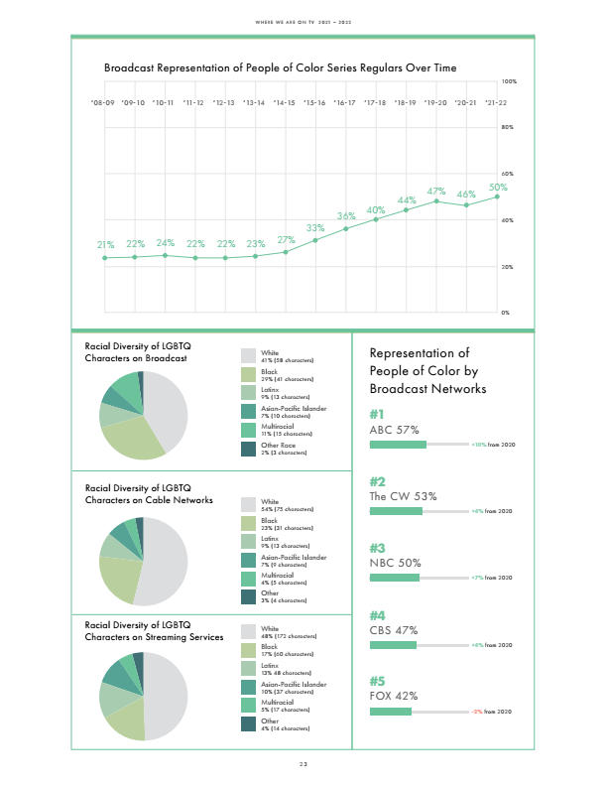
Figure 1. Racial diversity breakdown from GLAAD's 2021/2022 Where We Are On TV report.
Further, the report lacks a lot of qualitative information. Not all representation is good representation. Although the media censorship of homosexuality formally ended in 1968 with the abolishment of the Hays Code prohibiting explicit mentions of homosexuality in film and television, network censorship has still prevailed, limiting the number of LGBTQ+ characters and the amount of intimacy that queer couples have been allowed to show. During her tenure on Guiding Light, popular soap opera actress Crystal Chappell’s character Olivia Spencer was a man-eating schemer with multiple husbands and boyfriends, and several very intimate love scenes through her first eight years on the show. In the last two seasons, however, her character gradually fell in love with another woman, Natalia. In her autobiography, Chappell (2015) detailed network pushback to the couple, and stated that even kisses on the cheek were prohibited and left on the cutting room floor. Popular primetime shows such as Glee have also experienced similar issues, wherein Brittany and Santana were allotted several makeout scenes with male characters, but were not shown kissing each other for an entire season after admitting their feelings for each other. Kurt and Blaine were also more limited than their heterosexual counterparts. In fact, no such limitations have been imposed on heterosexual couples in decades, showing a clear unequal treatment of queer characters and couples on television.
However, the worst traps into which showrunners and writers have fallen are the common tropes which portray queer characters, at best, as two-dimensional beings defined primarily by their sexuality (e.g. the ‘GBF’ or ‘gay best friend’) or, at worst, in a damaging and negative light (e.g. the ‘psychotic lesbian’ or ‘depraved homo/bisexual’ tropes). In general, the characters most at risk of being defined only by tropes without being given more complex characterization or storylines are side or recurring, rather than main, characters. Yet, some TV shows like Pretty Little Liars feature main characters Emily (a lesbian) and Alison (a bisexual) but remain heavily involved among the worst perpetrators of harmful tropes. In fact, the show also boasted the most queer character deaths as part of a ‘Bury Your Gays’ narrative in American television (Hogan, 2017).
‘Bury Your Gays’ (BYG) has emerged as one of the most prevalent and problematic tropes in queer television representation particularly in the past couple of decades. It seems, as LGBTQ+ characters became more prevalent, queer deaths on television took a disproportionate rise. Although this trope affects male queer characters – notably and recently, Cas from Supernatural, who was killed off only moments after admitting his love for another male lead – it primarily affects sapphic or queer female characters to the extent that it is also known as ‘Dead Lesbian Syndrome.’ The trope does not cover every queer death; rather, it specifically refers to the often accidental and violent death of a queer character following an intimate scene with a partner of the same gender and/or a scene declaring their feelings for another person of the same gender meant only to further the storyline of another character, and is typically improperly grieved. An earlier example of this was the death of Tara on Buffy the Vampire Slayer, who was shot by a stray bullet intended for Buffy immediately following her first ever love scene with Willow in 2003. Thus, BYG is defined as much by the context as by the character’s death.
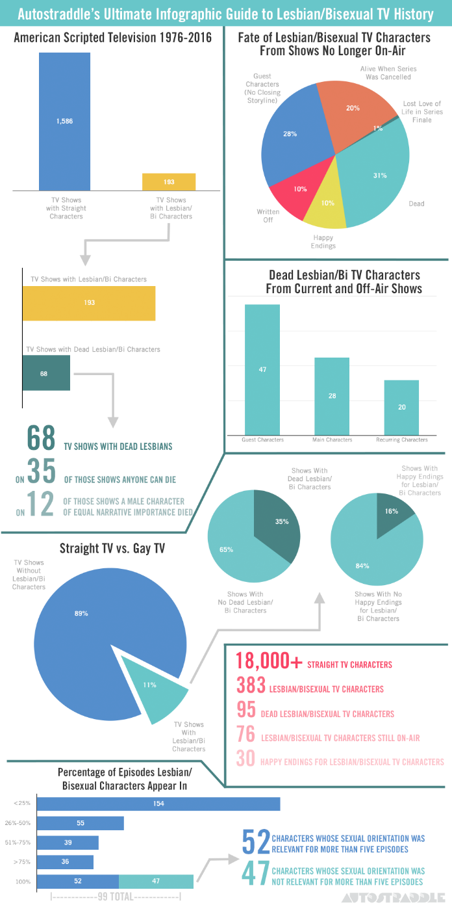
The trope came under fire in 2016 following the death of Lexa on the popular CW series The 100, who, like Tara, was hit by a bullet intended for someone else immediately following a love scene with her girlfriend, Clarke. Only one week later, The Walking Dead killed off lesbian character Denise with a stray arrow intended for someone else, and did not afford her death the same mourning given to other characters of similar run time (Deschler, 2017). By the end of March, over 40% of the queer female characters on television in 2016 were violently killed off and queer fans began an LGBT Fans Deserve Better campaign to end the televised violence against lesbians and bisexual women. A more complete tally of queer female deaths in television up to mid-2016 was conducted by the popular website Autostraddle and identified over 200 dead lesbian characters (Riese, 2016). Over 3/4 of these deaths took place between 2007 and 2016. To put this number into perspective, Autostraddle and AfterEllen released approximate breakdowns of the types of endings sapphic characters typically received and found that only about 10% had been given happy endings, while close to 50% were killed off.
In 2016, Autostraddle (Hogan, 2016) released an infographic (Figure 2) detailing some of the contextual factors of the BYG trope and its prevalence. As is evident from the numbers presented here, the data at the time of creation was incomplete and did not account for many of the character deaths included in subsequent articles. The graphic also includes heavy use of pie charts, and the layout is somewhat cluttered, and purposely unaligned for aesthetics rather than readability. Although important information is highlighted in point form text, intersectional factors – such as the races of characters who were killed off – were ignored. Despite pressure on the networks over the previous six years, in April 2022, the trope was shown alive and well with the murder of Villanelle on Killing Eve in the final minutes of the series finale, just after officially coupling with Eve. Riese (2022) recently updated their original post to include nine additional BYG casualties, including Villanelle. However, the trope has not been as closely tracked in recent years and is in need of further evaluation.
Figure 2. Autostraddle's (2016) Bury Your Gays infographic. Retrieved from https://www.autostraddle.com/autostraddles-ultimate-infographic-guide-to-dead-lesbian-tv-characters-332920/
Finally, while LGBTQ+ representation is on the rise, much of this diversity has focused on the axis of sexuality rather than gender identity. GLAAD reported less than 50 trans characters across networks and streaming, only 8 of whom were nonbinary. Many of these characters were clustered on the same shows. Transgender characters have been victims of tropes ranging from questionable representation (e.g. ‘The Non-Binary Non-Human’ and ‘Trans Fetishization’) to downright harmful (e.g. ‘Unsettling Gender Reveal’ and ‘The Mentally Unstable Trans Woman’). Transgender characters are often dehumanized and treated as punchlines. They are also often portrayed as aggressors, despite being more likely to be victims in the real world (Reynolds, September 25, 2020). Some recent analyses of trans characters in media have offered some hope that this landscape is changing, and that these characters are being portrayed with more complexity and humanity than ever before (Capuzza & Spencer, 2017; McLaren et al., 2021). However, these analyses also point out that transgender characters are often misgendered and referred to by the wrong name. In light of the previously-mentioned wave of anti-trans bills and the media’s power to help change public opinions, if ever there was a time when the quality of trans representation mattered, it is now.
The purpose of this study is to present LGBTQ+ representation data in a multisection, intersectional visual report using dynamic and interactive graphical displays. Visuals can be powerful storytelling tools when done well, and allow viewers to easily read and interpret a lot of data at once. Some research has indicated that visuals may even be more useful than written or numeric descriptions (Kinkedeley et al., 2017). Thus, the graphical data can serve as an easy diagnostic tool from which readers can draw their own conclusions without having to read an extensive report.
This project proposes to expand on GLAAD’s analyses and improve and update information on BYG as was begun by Autostraddle in 2016. This is intended to be in a website style, where each section represents a separate tab for organizational purposes and so as to avoid overwhelming the reader with too many graphics. Each section will have minimal accompanying text but clear titles, captions, and labels. Additionally, as suggested by Organ (2021), all colours will be colorblind friendly so that it will be accessible to more readers. The first section will use data from all 26 years of GLAAD’s reports to provide a brief look at representation over time, while the specific diagnostics of intersectionality will be designed to represent the state of queer and trans representation through the most recent season of American television. All sections will focus only on series regulars, and exclude recurring characters (any character in less than 3/4 of the episodes of a season) and guest spots.
This will begin with a general overview section, including a line graph of representation over time. In the same graph, there will also be a clearly labelled second line in a different colour tracking non-white LGBTQ+ characters by year for easy comparisons. These graphs are intended to be interactive such that hovering your mouse over a point on the graph will provide a numerical value of representation at that time in history as well as the percent breakdown by major network/streaming service top five networks. Alternatively, there could be manual options to toggle select specific networks so that patterns can be seen by network across time. Following, but on the same scale for easy comparisons, there will be similar graphs for lesbians, gay men, bisexuals+ (i.e. includes all multigender attractions), and transgender characters (non-binary inclusive). These graphs will be similar to graphs already featured in GLAAD’s reports; however, in accordance with recommendations from Cleveland and McGill (1984), the graphs will be altered to be more minimalistic (e.g. including no background grid), and include clearer colours rather than faded blues/greens and greys, in addition to the interactive component. Since only two lines are included, the lines will be clearly labelled on the graph, as opposed to using a legend. This section will therefore provide quick and easy takeaways of both LGBTQ+ and queer POC representation at a glance, and allow us to view any relationships between individual identities and race quickly.
The next section of the report will focus more closely on intersections; particularly with race. First, this will be a similar percent breakdown as GLAAD features; however, instead of pie charts and horizontal bar charts, this will be done using vertical bar charts for easier comparisons so that height, rather than length can be compared. This graph will be dynamic such that the user can select overall representation or select specific identities to view the breakdown only for that category. All values will be presented such that hovering over the bar will show the numerical value for that bar so that the reader can receive exact, rather than approximate, values. Additionally, graphs will be on the same scale to make comparisons.
This section will also feature multivariate graphs of disability, race, and identity. These displays will divide disabilities into categories of mental (e.g. PTSD), physical (e.g. wheelchair user, long-term illness), and developmental (e.g. autism, Down syndrome), rather than treating it as a single-level variable as previous reports have done. For each category, similar graphs of race will then be used to describe the race and gender/sexuality of disabled characters to assess that level of intersectionality. If data on socio-economic status of LGBTQ+ characters is available, similar plots will be generated to assess approximate class. Essentially, this section aims to visualize all intersections possible, given the data, in one neat area where comparisons are easily made.
A subsection of the above will also specifically focus on the diversity of representation of transgender and nonbinary characters. This is intended to highlight the lack of trans representation on television as well as to assess diversity of the characters who do exist. Every graph will also have proportions of each category representing trans men, trans women, and non-binary characters. Given that GLAAD identified only 42 trans and non-binary characters on television in 2021/2022, a more in-depth analysis is also possible. Inspired by the breakdown Autostraddle provided of endings for sapphic characters, there will also be an analysis of the situations of trans characters. However, this will be done in a bar chart style, as opposed to a pie chart. This visual will be used to assess whether trans characters are more likely to be portrayed in negative or damaging scenarios compared to their cisgender counterparts.
Finally, the last section will focus on the Bury Your Gays trope as a dynamic timeline of queer deaths on television in the past 20 years. This is, in part, inspired by the Out of Sight, Out of Mind project of drone strike attacks, where each death will be presented in chronological order onto the same timeline until the most recent death at the time of data collection. The purpose of this is to indicate how closely together many of the deaths were clustered and to assess the extent to which BYG deaths have waned since 2016. Additionally, this is meant to highlight the impact of these deaths on the audience by showing them separately, rather than all at once. Following, there will be an icon graph visual with an icon representing each death per year, wherein characters who were killed will be coloured according to sexuality/gender identity. Finally, a line graph will compare the number of overall BYG tropes with two additional lines representing disabled queer characters and queer characters who are also people of colour. A breakdown will be provided below of the proportions of specific races and disabilities.
Overall, this project is intended to be a widescale analysis of the current state of television representation, with some look at progression over time. Using data originally presented by GLAAD and Autostraddle as its starting point, the project aims to provide clear and readable visuals that not only incorporate quantitative discussions but also look at some qualitative aspects; notably, to examine multiple axes of intersection, as well as provide a qualitative look at transgender representation and the Bury Your Gays trope. This will not only provide information to television audiences but also highlight areas which are lacking or problematic, and allow for stronger recommendations to networks in the future. Representation has been found to have important impacts on both queer and cisgender heterosexual audience members, so it is time we make sure television is getting it right.

References

Birchmore, A. & Hensmann Kettrey, H. (2021.) Exploring the boundaries of the parasocial contact hypothesis: An experimental analysis of the effects of the “bury your gays” media trope on homophobic and sexist attitudes. Feminist Media Studies. doi: 10.1080/14680777.2021.1887919
Butler, J. (2004.) Precarious Life: The Powers of Mourning and Violence. London, NY: Verso.
Capuzza, J.C. & Spencer, L.G. (2017.) Regressing, progressing, or transgressing on the small screen? Transgender characters on U.S. scripted television series. Communication Quarterly, 65(2), 214-230. doi: 10.1080/01463373.2016.1221438
Cleveland, W.S. & McGill, R. (1984.) Graphical perception: Theory, experimentation, and application to the development of graphical methods. Journal of the American Statistical Association, 79(387), 531-554. doi: 10.1080/01621459.1984.10478080
Deshler, K. (2017.) Not Another Dead Lesbian: The Bury Your Gays Trope, Queer Grief, and The 100. [Honours Thesis, Whitman College. Penrose Library.
Driver, S. (2007.) Queer Girls and Popular Culture: Reading, Resisting, and Creating Media. New York, NY: Peter Lang.
GLAAD Media Institute. (2022.) Where We Are On TV 2021/2022. Gay and Lesbian Alliance Against Defamation. https://www.glaad.org/sites/default/files/GLAAD%20202122%20WWATV.pdf
Goddard, M.N. & Hogg, C. (2019.) Streaming intersectionality: Queer and trans television aesthetics in post-medium transformation. Critical Studies in Television: The International Journal of Television Studies, 14(4), 429-434. doi: 10.1177/1749602019875846
Gomillion, S.C. & Giuliano, T.A. (2011.) The influence of media role models on gay, lesbian, and bisexual identity. Journal of Homosexuality, 58(3), 330-354. doi: 10.1080/00918369.2011.546729
Hogan, H. (2016, March 25.) Autostraddle’s Ultimate Infographic Guide to Dead Lesbian Characters on TV. Autostraddle. https://www.autostraddle.com/autostraddles-ultimate-infographic-guide-to-dead-lesbian-tv-characters-332920/
Hogan, H. (2017, August 3) Pretty Little Liars Has Now Killed More Queer and Trans Women than Any Other Show. Autostraddle. https://www.autostraddle.com/pretty-little-liars-has-now-killed-more-queer-and-trans-women-than-any-other-tv-show-347270/
Kinkeldey, C., MacEachren, A.M., Riveiro, M., & Schiewe, J. (2017). Evaluating the effect of visually represented geodata uncertainty on decision-making: Systematic review, lessons learned, and recommendations. Cartography and Geographic Information Science, 44(1), 1-21. doi: 10.1080/15230406.2015.1089792
Lewis, G.B. (2011.) The friends and family plan: Contact with gays and support for gay rights. Policy Study Journal, 39(2), 217-238. doi: 10.1111/j.1541-0072.2011.00405.x
Madzarevic, G. & Soto-Sanfiel, M.T. (2018.) Positive representation of gay characters in movies for reducing homophobia. Sexuality & Culture, 22, 909-930. doi: 10.1007/s12119-018-9501-x.
Mazur, M.A. & Emmers-Sommer, T.M. (2002.) The effect of movie portrayals on audience attitudes about nontraditional families and sexual orientation. Journal of Homosexuality, 44(1), 157-181. doi: 10.1300/J082v44n01_09
McLaren, J.T., Bryant, S. & Brown, B. (2021.) “See me! Recognize me!” An analysis of transgender media representation. Communication Quarterly, 69(2). doi: 10.1080/01463373.2021.1901759
Organ, N. (2021, July 11.) An Incomplete Guide to Accessible Data Visualization. Towards Data Science. https://towardsdatascience.com/an-incomplete-guide-to-accessible-data-visualization-33f15bfcc400
Petermon, J.D. & Spencer, L.G. (2019.) Black queer womanhood matters: Searching for the queer herstory of Black Lives Matter in television dramas. Critical Studies in Media Communication, 36(4), 339-356. doi: 10.1080/15295036.2019.1607518
Reynolds, E. (2020, September 25.) Books and movies keep creating transgender aggressors. But trans people are far more likely to be victims of violence. CNN. https://www.cnn.com/2020/09/25/entertainment/transgender-jk-rowling-media-intl/index.html
Riese. (2022, March 31.) All 225 Dead Lesbian and Bisexual Characters on TV and How They Died. Autostraddle. https://www.autostraddle.com/all-65-dead-lesbian-and-bisexual-characters-on-tv-and-how-they-died-312315/
Schippa, E., Gregg, P.B. & Hewes. (2006.) Can one TV show make a difference? Will & Grace and the parasocial contact hypothesis. Journal of Homosexuality, 51(4), 15-37. doi: 10.1300/J082v51n04_02

