Visualizing the Relationship Between Simultaneous Alcohol and Marijuana Use

Emma Ritchie
PSYC 6135: Psychology of Data Visualization
Dr. Michael Friendly
April 25, 2022

Visualizing the Relationship Between Simultaneous Alcohol and Marijuana Use

Background and Relevant Research
Simultaneous alcohol and marijuana (SAM) use is the consumption of alcohol and marijuana products concurrently. SAM use is associated with higher rates of problematic drinking (Shillington & Clapp, 2001; Shillington & Clapp, 2006) and a myriad of negative mental health and social consequences, such as depression (Pacek et al., 2012), physical injuries (Harrington et al., 2012), and greater risk of driving under the influence (Bramness et al., 2010). Despite these risks, it is estimated that approximately 73% of Canadians aged 18-25 use alcohol and marijuana simultaneously (Bravo et al., 2021). Research into motivations underlying SAM use Researchers have theorized that this high proportion of SAM use is motivated by a desire to experience the synergistic, or cumulative, effects of using each substance together (Yurasek et al., 2017).
There is some evidence from laboratory experiments that support the notion that the combination of marijuana and alcohol can create positive effects that last longer than if either substance was consumed separately (Lukas & Orozco, 2001; Hartman et al., 2016). Alcohol consumption has been found to initially increase blood levels of tetrahydrocannabinol (THC), the psychoactive component of marijuana (Lukas & Orozco, 2001; Hartman et al., 2015; Hartman et al., 2016). Low doses of marijuana and alcohol can create positive effects that last longer than if either substance was consumed separately (Lukas & Orozco, 2001; Hartman et al., 2016). In contrast, low doses of marijuana combined with high doses of alcohol has been shown to prevent a rise in plasma alcohol levels, corresponding to the experience of fewer positive effects with shorter duration (Lukas & Orozco, 2001; Yurasek et al., 2017). As such, it is possible that THC actually lessens the subjective effects of alcohol (Ballard & de Wit, 2011).
One way to better understand why simultaneous use occurs is to focus on the cognitive mechanisms underlying simultaneous use. It is possible that cross-cue reactivity is at least partially responsible for SAM. Cross-cue reactivity occurs when two behaviours, for instance consumption of alcohol and marijuana, are frequently paired together. The principles of classical conditioning suggest that these behaviours will become strongly associated with each other, such that alcohol by itself elicits thoughts, behaviours, and cravings for marijuana (and vice versa) (Tiffany & Carter, 1999). Theoretically, if cross-cue reactivity occurs, then someone under the influence of alcohol could experience cravings for marijuana. They might become more attuned to marijuana-related cues or become more motivated to seek out marijuana in order to consume it. Additionally, cravings for marijuana could trigger actual use of it. All of cue-elicited reactions could potentially explain why simultaneous use occurs. While there is a robust literature on this phenomenon in alcohol and tobacco co-use (Ritchie et al., 2021), there is very little research on cross-cue reactivity between alcohol and marijuana.
While cross-cue reactivity may help to explain why SAM occurs, there has been little qualitative research on this topic. A recent 2021 paper by Boyle and colleagues examined motivations behind SAM use in college students who drank heavily and found that motives for use generally mapped onto the four-factor model for drinking, where people are hypothesized to drink for coping, social, enhancement, and/or conformity reasons (Blackwell & Conrod, 2003). This aligns with findings from Patrick et al. (2018), who developed the Simultaneous Alcohol and Marijuana Motives Measure (SMM) based on the four-factor model of drinking motives. This suggests that motivations for SAM use are heterogenous and multi-faceted. A qualitative perspective on this phenomenon is not only important but, I would argue, critical towards our understanding of SAM use. It seems outrageous that we would study something that occurs in people without actually asking those people why they are doing what they are doing. Cross-cue reactivity can theoretically occur at both an unconscious and a conscious level: someone may know that they are triggered to use marijuana while under the influence of alcohol, but others may not understand what is influencing them to behave or think in a certain way.

Goal of the Proposed Study
The primary aim of the proposed study is to examine whether there is evidence that cross-cue reactivity is one of the mechanisms by which SAM use occurs. A mixed-methods approach is proposed in order to address the research question from two different, but equally important, angles. The proposed study aims to use mixed-methods for completeness (“to ensure total representation of experiences” [Caruth, 2013, p. 113]) and corroboration/confirmation (“to evaluate the trustworthiness of inferences gained from one method” [Caruth, 2013, p. 113]) purposes.
The secondary aim of the proposed study is to present the results of both the qualitative and quantitative portions in a visually impactful way. As will be explained below, we intend to use eye-tracking as one means to assess whether cross-cue reactivity occurs in SAM use. There are many ways to represent eye-tracking data visually, depending on the nature of the eye-tracking study and the data (Raschke et al., 2017). The eye-tracking portion of the proposed study will focus on analyzing areas of interest (AOIs) on static (non-moving) stimuli, which are pre-defined areas in the eye-tracking stimuli that will be used as a measure of attention towards those stimuli (Raschke et al., 2017). Scarfplots will be the primary method used to visualize the eye-tracking data, and will be discussed in further detail below.
We also intend to present the qualitative results using network analysis (Pokorney et al., 2017). Qualitative studies are rich in information and this complexity can be difficult to convey. In addition, qualitative research has been criticized for being non-transparent, as the process of generating themes and/or codes in qualitative studies is usually not conveyed in the study, only the end results (i.e., the final themes/codes) (Pokorney et al., 2017). Network analysis offers a solution to these difficulties by depicting qualitative data as a network. In a qualitative network, each code is represented as a node, and the edges between codes are the relationships between codes (Figures 1 and 2). We intend to use network analysis to represent subject code networks. As discussed in Pokorney et al. (2017), subject coding is used to better understand what is being talked about in qualitative data. More detail on this will be discussed in the Plan for Data Visualization section.

Figure 1. A classic depiction of a network. The teal circles represent nodes and the red lines represent edges.

Figure 2. The adaptation of a network to qualitative data. The relationship between codes represents the edge (red lines), and the nodes are the codes (teal circles).

Why Use Eye-Tracking to Study Cross-Cue Reactivity?
Theoretically, if cross-cue reactivity between alcohol and marijuana occurs, then exposure to an alcohol cue could lead to the simultaneous user to become more attuned to stimuli related to marijuana (and vice versa). When a stimulus acquires salience in this process, an attentional bias can occur. An attentional bias is the irrepressible tendency to preferentially attend to certain stimuli over others (Ciccarelli et al., 2016); it is typically measured using eye-tracking technology. Use of eye-tracking in this way means that we can directly assess where people are allocating their attention via what they are actually looking at. Eye-tracking has been shown to be an internally reliable method of assessing attentional biases (Field et al., 2014). This study proposes that one way we can empirically examine cross-cue reactivity is by assessing attentional biases, which is why eye-tracking will be used as one way to measure cross-cue reactivity.

Proposed Methodology
In the interest of transparency, I would like to make it clear that the proposed methodology is partially based off of my unpublished Master’s thesis (Ritchie, 2019). The purpose of that study was to examine cross-cue reactivity between alcohol and gambling. The eye-tracking design in the proposed study is similar to Ritchie (2019), but the cue exposure has been changed and a qualitative component has been added.
This will be a between-subjects study where all participants are simultaneous users of alcohol and marijuana. Definitions of SAM users vary across studies, so this study will take a moderate approach and propose that they must use marijuana when they drink alcohol at least 50% of the time. Participants will be randomly assigned to the alcohol or placebo condition. For the alcohol condition, participants would consume one standard drink in order to reach a blood alcohol concentration (BAC) of .02 to .03, representing mild intoxication. For the placebo condition, participants would be asked to consume a mixed drink with alcohol rubbed on the rim to give the illusion that there was alcohol in it.
All sessions will be audio recorded and transcribed after the session. There will be set questions at several time points in the study in order to assess cross-cue reactivity; these will be one of the targets for the qualitative analyses. Participants will not be prompted as to whether they are craving marijuana until after BAC has been reached (alcohol condition) or when they have finished the beverage (placebo condition). At that point, participants will be asked: “How much do you crave marijuana right now? What is your reasoning for that rating (why do you think you are or are not craving it?) If you were given the opportunity to consume it right now, would you take it?”
Participants would then be asked to complete an eye-tracking task. The eye-tracking task would consist of 80 trials with two images per trial. Forty of these trials would contain one marijuana image and one images that looked similar to the marijuana image in colour or content, but were not pictures of marijuana (e.g., pictures of a green landscape, herbs, or nature) (example trial pairing in Figure 3). The rest of the trials would contain similar pictures as these “filler” images. After the eye-tracking task, the participants would again be asked: “How much do you crave marijuana right now? What is your reasoning for that rating (why do you think you are or are not craving it?) If you were given the opportunity to consume it right now, would you take it?” All participants would also be asked to fill out questions on demographics and marijuana and alcohol use history. Finally, participants would be asked to describe to the researcher about how they personally believed their alcohol and marijuana use is related, and what motivates them to use these substances at the same time.

Figure 3. An example cannabis (right) vs. neutral (left) trial pairing for the proposed study. The orange and yellow boxes indicate the areas of interest (AOIs) for each stimuli. The boxes would not be present in the eye-tracking study and are shown here to depict to the reader what the AOIs would be.
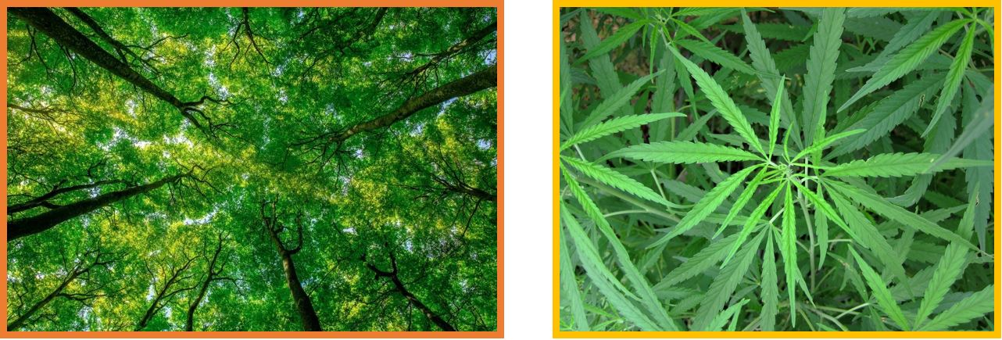
Plan for Data Visualization
Eye-Tracking Visualization. In their excellent review of available eye-tracking visualization methods, Raschke et al. (2017) recommended several possibilities for an eye-tracking researcher who primarily uses AOIs as their dependent variable in an eye-tracking analysis. From these suggestions, I have selected three that could potentially be of use in the proposed study. The first is a scarf plot. Scarf plots allow the aggregation of data from different participants. Each AOI is assigned a colour. As an example, the neutral stimuli from Figure 3 could be assigned the colour orange, and the marijuana stimuli could be assigned the colour yellow. As shown in Figure 4, each participant’s eye-tracking data for a given trial (or more, depending on how complex you want the scarfplot to be) would be converted to reflect which AOI they were looking at in each second of the trial. For example, in Figure 4, Participant 2 initially looked at the neutral stimuli, then spent the rest of the trial looking at the marijuana stimuli. This could be useful to visually depict and contrast the two groups (alcohol vs. placebo) and how they allocated their attention over the duration of the task. Scarfplots can get complex

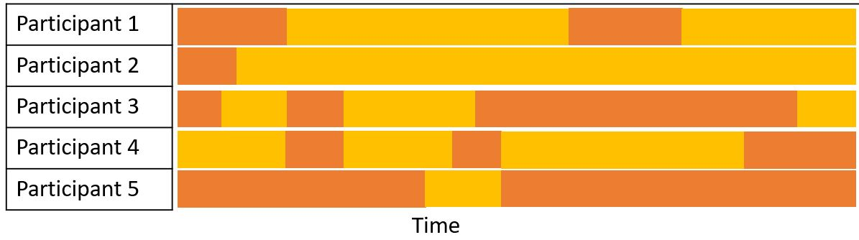
Figure 4. An example scarfplot (not based on any real data). Each colour corresponds to a different AOI for one trial in the proposed eye-tracking task.

with more AOIs, so it would be up to the researcher to decide the best way to visually depict the results using a scarfplot. My initial thought would be to use the results from about 25% of the neutral vs. marijuana trials (n = 10 trials) and have a separate plotscarf for each of experimental groups. This would highlight the differences in attentional biases between the two groups in a condensed and easy-to-understand way. This offers a large advantage over the only way I typically see eye-tracking data for this type of study design depicted in papers, as shown in Figure 5. In Figure 5, the eye-tracking data for a single participant for a single trial is shown. While it is certainly interesting to look at to better understand eye movements and how this particular participant allocated their attention, it does not give us any information about the results of the study at large.

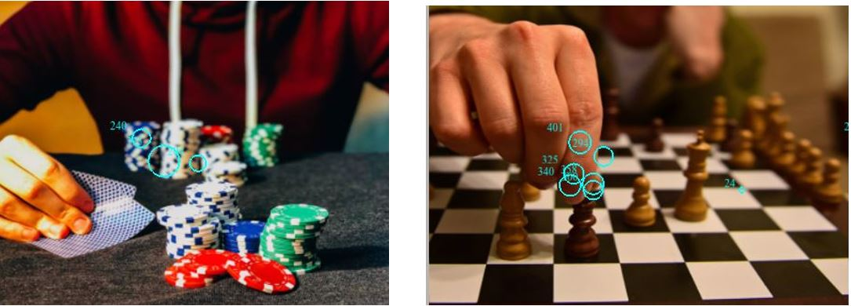
Figure 5. An example of eye-tracking data visualization from my Master’s thesis (Ritchie, 2019). This is from a single trial with a single participant. Each blue circle indicates where this participant fixated in each AOI. The larger circle indicate that longer was spent fixated on that point.

Network Analyses for Qualitative Data. We are interested in two separate qualitative analyses from the proposed study. First, we want to know how participants’ experience of craving for marijuana changed over time as their BAC levels rose and they viewed images of marijuana in the eye-tracking task. In their review of network analysis, Pokorney et al. (2017) were specifically interested in the chronological location of codes, which we are as well, therefore we can directly adapt their recommendations for our network analysis. Specifically, we are interested in creating a network that shows the flow of codes and themes temporally (Pokorney et al., 2017). As mentioned earlier, we will take a subject coding approach to this part of the qualitative analyses (i.e., when marijuana cravings were assessed). Subject coding takes the point of view that the coding is prompted by the data instead of fitting the codes to preconceived notions of what the data should look like (Pokorney et al., 2017). Each code will be assigned a colour in the network graph. The size of each node will correspond to the node’s relative importance within the network (i.e., was it discussed frequently among participants? Is it related to other codes within the network?). The edges, or connections between the nodes, will represent the chronological location of the codes – this will allow the network to reflect the experience of marijuana craving (or lack of it) across time. Separate network analyses will be done for each condition, as we would expect marijuana craving to remain low for the placebo group. Depicting these networks separately will also allow us to compare and contrast the experiences of the two groups visually.
We are also interested in a separate analysis for the questions asked at the end of session: How do you think your alcohol and marijuana use is related? What motivates you to use these substances at the same time? A subject coding approach also seems like the best approach to this data in order to truly understand the motivations behind SAM use.

Proposed Statistical Analyses
In addition to the data visualization techniques proposed, a series of ANOVAs will be run in order to assess the effect of condition (alcohol vs. placebo) on attentional biases for marijuana. If cross-cue reactivity is occurring between marijuana and alcohol, we would expect that those in the alcohol condition would be more attuned to the marijuana stimuli than those in the placebo condition. As such, we would expect to see greater evidence of attentional biases for marijuana stimuli, as displayed by more time spent looking at marijuana stimuli and higher fixation counts (i.e., looked at the marijuana stimuli multiple times) in the alcohol condition compared to the neutral condition.

Conclusion
The proposed study represents a novel method for investigating the relationship between SAM use. First, the use of eye-tracking to study attentional biases for marijuana provides us with highly internally reliable and objective data (Field et al., 2014) to evaluate the phenomenon of cross-cue reactivity. The proposed data visualization technique is unique and not frequently seen in psychological eye-tracking research, and will serve to better visualize the complexity of this data than previous methods such as those shown in Figure 5. Second, the qualitative component of this study will shed some much needed light on SAM use by asking people who 1) use marijuana and alcohol simultaneously, and 2) are currently under the influence of alcohol what their actual experience of wanting or craving marijuana is in real time. This is a novel method of examining cross-cue reactivity and will provide detailed and rich information into the thought processes of people potentially influenced by this phenomenon. Additionally, by incorporating network analysis into the visualization of the qualitative data in this study, we will be able to convey the results of our study appropriately and accurately in a visually appealing and logical way – something that is truly unique in the qualitative analyses world.

References
Ballard, M. E., & de Wit, H. (2011). Combined effects of acute, very-low-dose ethanol and
delta(9)-tetrahydrocannabinol in healthy human volunteers. Pharmacology Biochemistry
and Behavior, 97(4), 627-631. https://doi.org/10.1111/j.1360-0443.2010.02911.x
Blascheck, T., Kurzhals, K., Raschkje, M., Burch, M., Weiskopf, D., & Ertl, T. (2017).
Visualization of eye tracking data: A taxonomy and survey. Computer Graphics Forum,
36(8), 260-284. https://doi.org/10.1111/cgf.13079
Boyle, H. K., Gunn, R. L., López, G., Fox, O. S., & Merrill, J. E. (2021). Qualitative
examination of simultaneous alcohol and cannabis use reasons, evaluations, and patterns
among heavy drinking young adults. Psychology of Addictive Behaviors, 35(6), 638
649. https://doi.org/10.1037/adb0000746
Bramness, J. G., Khiabani, H. Z., Mørland, J. (2010). Impairment due to cannabis and ethanol:
Clinical signs and additive effects. Addiction, 105(6), 1080-1087.
https://doi.org/10.1111/j.1360-0443.2010.02911.x
Bravo, A. J., Prince, M. A., Pilatti, A., Mezquita, L., Keough, M. T., Hogarth, L., & Cross-
Cultural Addictions Team. (2021). Young adult concurrent and simultaneous use of
alcohol and marijuana: A cross-national examination among college students in seven
countries. Addictive Behaviour Reports, 14, Article 100373.
https://doi.org/10.1016/j.abrep.2021.100373
Carter, B. L., & Tiffany, S. T. (1999). Meta-analysis of cue-reactivity in addiction research.
Addiction, 94(3), 327-340.
Caruth, G. D. (2013). Demystifying mixed methods research design: A review of the literature.
Mevlana International Journal of Education, 3(2), 112-122.
https://doi.org/10.13054/mije.13.35.3.2
Ciccarelli, M., Nigro, G., Griffiths, M. D., Cosenza, M., & D’Olimpio, F. (2016). Attentional
biases in problem and non-problem gamblers. Journal of Affective Disorders, 198, 135-
141. https://doi.org/10.1016/j.jad.2016.03.009
Field, M., Marhe, R., & Franken, I. H. A. (2014). The clinical relevance of attentional bias in
substance use disorders. CNS Spectrums, 19, 225-230.
https://doi.org/10.1017/S1092852913000321
Hartman, R. L., Brown, T. L., Milavetz, G., Spurgin, A., Gorelick, D. A., Gaffney, G., &
Huestis, M. A. (2015). Controlled cannabis vaporizer administration: Blood and plasma
cannabinoids with and without alcohol. Clinical Chemistry, 61(6), 850–869.
https://doi.org/10.1373/clinchem.2015.238287
Hartman, R. L., Brown, T. L., Milavetz, G., Spurgin, A., Gorelick, D. A., Gaffney, G., &
Huestis, M. A. (2016). Controlled vaporized cannabis, with and without alcohol:
Subjective effects and oral fluid-blood cannabinoid relationships. Drug Testing and
Analysis, 8(7), 690–701. https://doi.org/10.1002/dta.1839
Harrington, M., Baird, J., Lee, C., Nirenberg, T., Longabaugh, R., Mello, M. J., & Woolard, R.
(2012). Identifying subtypes of dual alcohol and marijuana users: A methodological
approach using cluster analysis. Addictive Behaviour, 37(1), 119–123.
https://doi.org/10.1016/j.addbeh.2011.07.016
Lukas, S. E., & Orozco, S. (2001). Ethanol increases plasma Delta(9)-tetrahydrocannabinol
(THC) levels and subjective effects after marihuana smoking in human volunteers. Drug
and Alcohol Dependence, 64(2), 143-149.
Pacek, L. R., Malcolm, R. J., Martins, S. S. (2012). Race/ethnicity differences between alcohol,
marijuana, and co-occurring alcohol and marijuana use disorders and their association
with public health and social problems using a national sample. American Journal of
Addictions, 21(5), 435–44. https://doi.org/10.1111/j.1521-0391.2012.00249.x
Patrick, M. E., Fairlie, A. M., & Lee, C. M. (2018). Motives for simultaneous alcohol and
marijuana use among young adults. Addictive Behaviours, 76, 363-369.
https://doi.org/10.1016/j.addbeh.2017.08.027
Pokorney, J. J., Norman, A., Zanesco, A. P., Bauer-Wu, S., Sahdra, B. K., & Saron, C. D.
(2017). Network analysis for the visualization and analysis of qualitative data.
Psychological Methods, 23(1), 169-183. https://doi.org/10.1037/met0000129
Ritchie, E. V. (2019). The effect of alcohol cue exposure on gambling-related attentional biases
and cravings among poker players who drink. [Unpublished master’s thesis]. University
of Calgary.
Ritchie, E. V., Fitzpatrick, C., Ronksley, P., Leung, A., Seidel, S., & McGrath, D. S. (2021).
The effect of alcohol cue exposure on tobacco-related cue reactivity: A systematic
review. Alcohol and Alcoholism, Article agab009. https://doi.org/10.1093/alcalc/agab009
Shillington, A. M., & Clapp, J. D. (2001). Substance use problems reported by college students:
Combined marijuana and alcohol use versus alcohol-only use. Substance Use and
Misuse, 36(5), 663-672. https://doi.org/10.1081/ja-100103566
Shillington, A. M., & Clapp, J. D. (2006). Heavy alcohol use compared to alcohol and marijuana
use: Do college students experience a difference in substance use problems? Journal of
Drug Education, 36(1), 91-103. https://doi.org/10.2190/8PRJ-P8AJ-MXU3-H1MW
Venkatesh, V., Brown, S. A., & Bala, H. (2013). Bridging the qualitative-quantitative divide:
Guidelines for conducting mixed methods research in information systems. MIS
Quarterly, 37(1), 21-54.
Yurasek, A. M., Aston, E. R., & Metrik, J. (2017). Co-use of alcohol and cannabis: A review.
Current Addiction Reports, 4, 184-193. https://doi.org/10.1007/s40429-017-0149-8

