The Role of Spoken Language in Graphical Perception
Introduction
Designers of data visualizations often go to great lengths to ensure that their visualizations are easily and properly understood. However, not all individuals perceive, interpret, and understand visualizations in the same way. In addition to visual disorders which impair perception of colour, such as colour-blindness, there exist several individual differences which do not affect an individual’s visual system but nonetheless affect their perception of graphs.
In the field of human-computer interactions, Peck et al. (2012) propose a tripartite model of individual cognitive differences to explain why individuals differ in conducting interactions, consisting of cognitive traits, cognitive states, and experience/bias. Cognitive traits refer to both cognitive skills and personality traits, cognitive states refer to both cognitive load and emotional state, and experience/bias simply refers to the learned behaviours, or lack thereof, which affect graphical perception.
Liu et al. (2020) argue that this model can easily be applied to data visualization. Cognitive traits, such as working memory and neuroticism, have known to correlate with individual performance on data visualization tasks (see Liu et al., 2020 for review). Individuals also perform differently on tasks after being primed, thus influencing their cognitive state; for instance, visual judgment improves after one is successfully primed to feel positive emotion (Harrison et al., 2013). A variety of experiences and biases can be relevant towards graphical perception, including not only familiarity with graphs (Ciccione et al., 2023) but profession (Hall et al., 2022) and political alignment (Peck et al., 2019).
One individual cognitive difference that may affect how one experiences and interprets data visualization is languages. The language that one speaks has been known to influence visual perception. However, the vast majority of data visualization research has been conducted in English, using English speakers as participants, meaning that these possible linguistic differences have not been addressed (Rakotondravony et al., 2023).
The proposed pair of studies will assess how one’s spoken language affects their performance on graphical tasks, specifically with regards to colour. While spoken language is an example of an experience/bias according to the individual cognitive differences model, it may be possible to “prime” a multilingual individual to perceive graphs in accordance with one of their spoken languages over the other(s), suggesting that language may function as a cognitive state in some cases.

Background

Categorical Perception of Colour
Humans may perceive continuous phenomena as being divided into categories, a phenomenon known as categorical perception. Categorical perception was first observed in speech perception, but is controversial in the field (McMurray, 2022). One area of research where categorical perception has taken off is colour perception. There are no clear boundaries between different colours, but the human perceptual system creates seemingly arbitrary boundaries (Lindsey & Brown, 2021).
Categorical perception of colour appears to have innate and learned components. The basic colour terms of the language that one speaks affect one’s perception of colour. Basic colour terms (e.g., blue, green, red) are single words commonly used by all speakers of a language that refer to an abstract concept of a colour as well as objects of that colour and are not contained within a broader colour category. Not all languages have equivalent basic colour terms. Whereas English has 11, some languages such as Japanese, Russian, and Turkish have a basic colour term for what English speakers would refer to as “light blue” as well as a basic colour term for “blue”, bringing their total up to 12. Others have fewer than 11, including those languages which use one basic colour term to refer to both green and blue such as Tarahumara (Lindsey & Brown, 2021).
Categorical perception of colour has both innate and learned elements. It has been observed in chimpanzees, as well as infants who have not yet acquired language, indicating that language is not entirely needed for categorical perception (Lindsey & Brown, 2021). However, there are numerous examples of categorical perception of colour based upon one’s spoken language. Witthoft et al. (2003) and Winawer et al. (2007) presented both Russian speakers and English speakers with a colour discrimination task (Fig. 1a), where they were shown three blue-coloured squares, and were tasked with identifying whether the left or right square was identical in colour to the middle. It was found that Russian speakers performed better when the two colours fell under two separate basic colour terms in the Russian language, whereas English speakers had no such advantage. Sinkeviciute et al. (2024) found the same effect when comparing speakers of Lithuanian, which divides blue similarly to Russian, to speakers of Norwegian, which has a single term for blue. In an experiment by Roberson et al. (2008), English and Korean speakers were required to find a differently-coloured “oddball” green square among identical green squares (Fig. 1b). The Korean language has two separate basic colour terms that encompass the English green, one representing “yellow-green” and the other for all other greens. When the oddball square fell under a different Korean basic colour term from the remaining squares, Korean speakers were quicker to identify the oddball than English speakers. A similar result was found by He et al. (2019), who performed the same task using blue squares with speakers of Mongolian, a language with separate terms for light and dark blue, and speakers of Chinese, a language with one term for blue. When the oddball square fell into a different colour category in Mongolian but not Chinese, Mongolian speakers enjoyed an advantage that Chinese speakers did not.
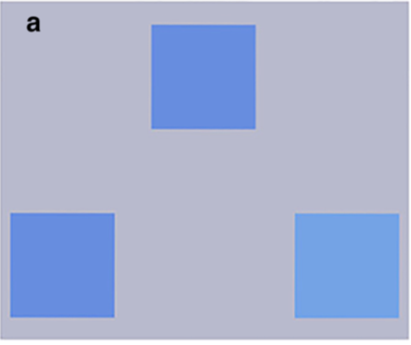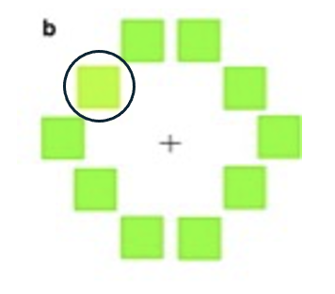
Fig. 1a: An example of a colour discrimination task, where participants had to identify as quickly as possible whether the bottom-left or bottom-right colour was different from the top-centre colour (the bottom-right square is different in the above image; Sinkeviciute et al., 2024); Fig. 1b: An example of an oddball task, where participants had to identify as quickly as possible the location of the one differently-coloured square (here, the differently coloured square is circled; Roberson et al., 2008)

Colour Scale Perceptions
Colour is a key component of most data visualizations. Different colours may be used to represent categorical data, in which case a qualitative colour palette, consisting of a finite number of colours, is often used (Fig. 2a; Wilke, 2019). Colours are typically chosen to be easily distinguishable from one another, or for their semantic resonance: pre-existing associations that viewers may have with particular colours (e.g., red for love or strawberries; Lin et al., 2013). For numerical data, a sequential colour scale is often used, consisting of a continuous colour gradient (Fig. 2b). The colour of an object is determined by taking its numerical value and finding the corresponding colour on the gradient. Sequential scales may consist of a single hue, with lighter variants at one end and darker variants at the other. In other cases, the gradient may have two separate diverging hues at both extremes, with intermediate values lying somewhere in between (Wilke, 2019).
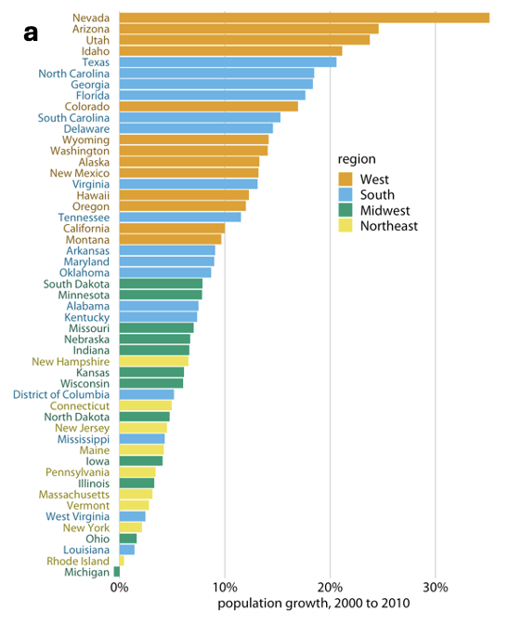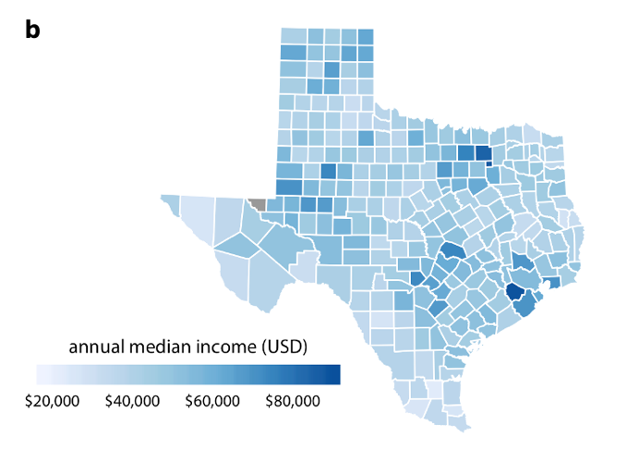
Fig. 2a: a bar graph showing proportional population growth of US states from 2000-2010 using a qualitative colour palette to represent region, a discrete, categorical variable; Fig. 2b: a choropleth map of Texas counties using a single-hue sequential colour scale to represent annual (as of 2015) median income, a continuous numerical value (Wilke, 2019)

The choice of colour scales in representation of sequential data is a contentious issue. Rainbow scales are increasingly maligned by the data visualization community, as they are not perceptually intuitive or chromatically uniform. Additionally, they are inaccessible to individuals with impaired colour vision. As such, either single-hue or divergent colour scales are recommended (Gołębiowska & Çöltekin, 2022). Additionally, some data visualizations will select a few discrete colours from a sequential colour scale, typically between four to six, to represent data “bins”, or ranges, sacrificing information but improving legibility (Wilke, 2019).
When choosing a colour scale, three distinct cultural or linguistic factors may be considered: name variation, name salience, and the aforementioned semantic resonance. Name variation refers to the number of separate nameable colours present in the scale: in other words, how many basic colour terms are represented. Name salience refers to how reliably identifiable the colours used in the gradient are. A colour that is universally associated with a basic colour term, such as blue, is more salient than a less prototypical colour that may be identified by some as turquoise, for instance. Both name variation and name salience can improve performance on visual search tasks. The linguistic features of a colour scale (e.g., name variation, name salience) may in fact contribute to improved task performance more than perceptual discriminability, a purely visual feature (Reda et al., 2021; Reda & Szafir, 2021).
Name variation and name salience are both relevant factors in choosing colour scales. They are also not universal. Colour scales will have different name variation and name salience to speakers of different languages with different basic colour terms. However, previous research on name variation and name salience has focused exclusively on English colour names (Reda et al., 2021; Reda & Szafir, 2021).

Experimental Background
In the pair of experiments by Reda and colleagues (Reda et al., 2021; Reda & Szafir, 2021) upon which this experiment is based, participants were shown a set of four data maps in a two-by-two arrangement coloured using a sequential scale (Fig. 3). Three of the maps were similar “decoys” sampled from the same fake “null” dataset, while the other represented true data. The decoys were not identical to one another but shared a resemblance which the true map lacked. Participants were tasked with identifying the “oddball” true map as quickly as possible. The purpose of this procedure was to model data inference.

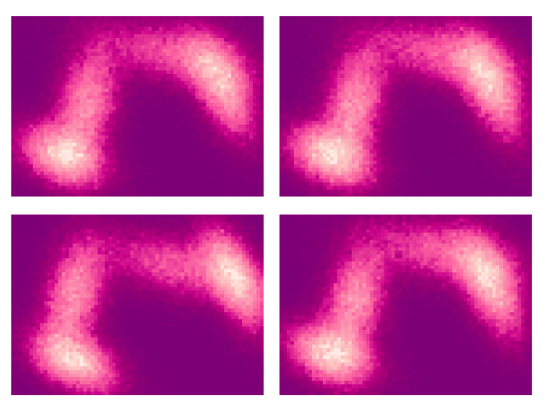
Figure 3: A two-by-two arrangement of data maps taken from Reda et al.’s (2021) experiment, in which a single-hue scale is used; in the above image, the oddball map is the in the bottom-left quadrant

Reda & Szafir (2021) used 12 different colour scales, including single-hue, divergent, and rainbow, assessed for name variation. Participants performed significantly better on trials which used scales with higher name variation, regardless of perceptual features. The colour scale plasma, for instance, was found to elicit more accurate trials than viridis (Fig. 4), despite similar perceptual properties. This was attributed to plasma having a higher rate of name variation than viridis.
Reda et al. (2021) replicated the previous experiment with six colour scales, assessed for both name variation and name salience. Both name variation and name salience were found to improve performance. The rainbow scale jet, for instance, was found to elicit more accurate trials than turbo (Fig. 4), despite the latter having more perceptual uniformity. This was attributed to jet having a higher rate of name salience than turbo.

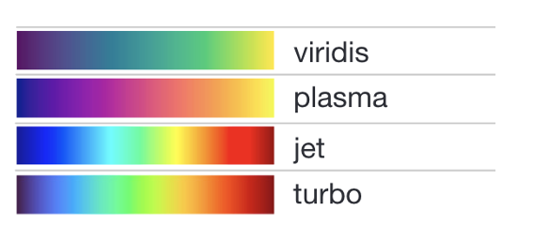
Figure 4: A selection of colour scales used by Reda and colleagues (Reda & Szafir, 2021)

Both name variation and name salience were measured according to a procedure outlined by Heer & Stone (2012). The colour names were taken from an online English-language colour categorization survey with over one hundred thousand participants. Semantic resonance was not addressed, though because it was not indicated what different colours on graphs represented, it was not relevant to either study (Reda et al., 2021; Reda & Szafir, 2021).

Language Background
For the pair of proposed studies, it is necessary to choose speakers of languages with different basic colour terms, but as few other sociocultural or linguistic differences as possible. The first group will be English speakers, as this was the language of the original experiment and the language of most data visualization research. There are many languages with different basic colour terms from English, but most can be ruled out immediately. The language of choice must be spoken in a WEIRD (Western, educated, industralized, rich, and democratic; Vinhas & Bastos, 2023) nation, and be as similar to English as possible. Additionally, the difference in basic colour terms must be well-established and consistent across all speakers of the language.
The requirement for a language spoken in a WEIRD nation immediately rules out most of the world’s languages with different basic colour terms, including Japanese, Korean, Mongolian, and Turkish. Eastern European countries are not considered WEIRD (Vinhas & Bastos, 2023), meaning that Russian and Lithuanian are excluded as well. Italian speakers are known to have more than one basic colour term for blue; however, the exact number of basic colour terms is disputed and may vary by dialect (Del Viva et al., 2022). While some Spanish speakers may have two basic colour terms for blue, this is primarily observed in the variety of Spanish spoken in Uruguay, a non-WEIRD nation (González-Perilli et al., 2017).
There are two languages which meet all the aforementioned criteria: Greek and Maltese. Both languages have two basic colour terms for what English speakers would consider blue (Borg, 2011; Coventry et al., 2006). However, a number of factors make Maltese an undesirable language for the purposes of this experiment. For one, while it uses the same writing system as English, it is not an Indo-European language, meaning it lacks a common ancestor with English. Additionally, there are comparatively very few Maltese speakers, and Maltese may also use English due to Malta’s status as a former British colony, meaning there may be some difficulty in finding study participants (Borg, 2011). As such, Greek has been identified as the ideal language for this study.
Modern Greek, an Indo-European language, uses 12 basic colour terms, 10 of which are near one-to-one translations of those used by English. The remaining two represent blue and light blue, respectively. The terms are used across multiple dialects, as well as by both monolinguals and bilingual English-Greek speakers (Coventry et al., 2006). Categorical perception of the two colours has been observed in Greek speakers using an oddball task (Thierry et al., 2009).
Because Greece is a WEIRD country, neither the level nor nature of education will differ significantly from similar nations in the Anglosphere. It is fair to assume that educated Greeks will have had some exposure to data visualization. It is also unlikely that semantic associations with colours will differ significantly.

Categorical Perception and Verbal Interference
For the second proposed experiment, a means of suppressing or activating the linguistic salience of colour is required. The procedure that will be used is verbal interference. Verbal interference refers to the usage of a task that is clearly linguistic in nature, such as committing a string of numbers to memory, for the purpose of “interfering” with verbal processing. This is done alongside with a primary task that may or may not be linguistic in nature, and if performance on the primary task is significantly impacted by verbal interference, then there is evidence that the primary task is indeed linguistic in nature (see Nedergaard et al., 2023 for review).
Categorical perception of colour is thought to be a linguistic phenomenon; evidence for this comes from studies which used verbal interference. Witthoft et al. (2003) found that categorical perception on a colour discrimination task disappears for English speakers when asked to memorize a string of numbers, a verbal task, but not the position of squares within a grid, a non-verbal task. On the same task, the performance of Russian speakers resembles that of English speakers when performing a verbal task but not a spatial one (Winawer et al., 2007; Witthoft et al., 2003), providing further evidence for the linguistic nature of categorical perception of colour.
However, for multilinguals, the reality is more complicated. Sinkeviciute et al. (2024) conducted a colour discrimination task with Lithuanian-Norwegian bilinguals. The individuals who performed this task were also asked to memorize a string of numbers in either Lithuanian or Norwegian as a verbal interference activity. Those who were given the string in Lithuanian distinguished between shades of blue more easily when they fell into different Lithuanian basic colour terms; those who were given the string in Norwegian did not. In other words, it may be possible to “prime” multilinguals to categorically perceive colours according to one of their spoken languages.

Experiment

Summary
The first proposed experiment will replicate the procedure of Reda and colleagues (Reda et al., 2021; Reda & Szafir, 2021), using a participant pool divided into speakers of English and Greek. Three single-hue colour scales will be used, consisting of blues, greens, and reds, respectively. Name variation and name salience for these scales will be assessed for both English and Greek.
If the first experiment shows that name variation is a predictor of performance in both English and Greek, a follow-up experiment is proposed, using the same procedure as the first. The participation pool will be identical to the first but with the addition of Greek-English bilinguals. Participants will perform both verbal and non-verbal interference tasks while completing the procedure.
For both experiments, details such as number of participants and number of trials will be determined by committee, based upon factors such as feasibility. The following will only outline basic components of the procedure that should be carried out regardless of these details.

Experiment 1: Participants
The proposed study will use two groups of participants: monolingual native speakers of English and of Greek. The former will be recruited from a university in an English-speaking WEIRD nation, and the latter from a university in Greece. Possible confounds include age, area of study, and prior exposure to data visualizations, all of which will be recorded for possible analysis. Both pools of participants should be matched in these factors. Participants will be tested for unimpaired colour vision; those who fail the test will be excluded.

Experiment 1: Colour scales
The proposed study will use three single-hue colour scales, with the hues being blue, green, and red, respectively. These three hues were selected to ensure different degrees of name variation in English and Greek. The green-hued scale should have low name variation in both English and Greek, as the colours are represented by only one basic term in both languages. Accordingly, the red-hued scale should have higher name variation in both languages, because, like English, Greek uses separate basic separate terms for red and pink/light red. The blue scale is expected to differ in name variation between both languages, given the differences in basic colour terms for blues (Coventry et al., 2006).
Because there is no Greek-language survey of colour terms, the colours used in the colour scales will have to be independently rated by Greek speakers. Name salience for each of the colour scales should also be assessed in both English and Greek. Scales should be chosen such that the name salience is as similar as possible in both languages without sacrificing perceptual distance.

Experiment 1: Procedure
After a tutorial explaining the procedure, participants will be shown four colour maps, one real and three from the same “decoy” dataset, all using one of the three selected colour scales (see Fig. 3 for example). Participants will not be given information about the data being represented on the colour map, only that they must choose the odd one out as quickly as possible, thus limiting the influence of semantic resonance. The maps will fill the entire rectangular area, as having recognizable shapes such as national borders may bias individuals who are familiar with regional maps. The rate of accurate trials for each participant will be measured, while trials that take over a certain amount of time will be excluded from analysis. While all participants will be shown the same series of maps, they will not be shown any one set of maps more than once. Each set of maps will be shown to an equal number of participants in each of the three colours.

Experiment 1: Hypothesis
Work by Reda & colleagues (Reda et al., 2021; Reda & Szafir, 2021) has indicated that name variation is correlated with performance on visual tasks. However, the direction of causality is unclear. It is possible that some colour scales are simply more visually salient, and that colour names reflect this. The usage of participants from different language groups allows name variation to be modulated without any change in perceptual features, thus allowing name variation to be studied in isolation. If name variation is indeed a factor in performance, then not only will all participants perform better on trials using the red colour scale than those using green, but their performance on trials using blue will vary based upon spoken language. More specifically, if name variation is a factor, Greek speakers’ performance on blue trials will resemble their performance on red trials, whereas English speakers’ will resemble their performance on green trials.

Experiment 2: Participants
The second proposed study will use three participant groups: monolingual native English speakers, monolingual native Greek speakers, and Greek-English bilinguals. If possible, the pool of monolinguals who participated in the previous experiment will participate again; otherwise, a new pool of monolingual participants will be recruited using the same methods as the previous experiment.
The third group, Greek-English bilinguals, should resemble the other two groups of monolinguals in factors such as age and educational status, and should have familiarity with data visualizations. Due to the status of English as a global language, native Greek speakers with advanced English proficiency are more prevalent than native English speakers with advanced Greek proficiency, and thus will be the primary focus of the recruitment phase. Recruitment for the bilingual group will be carried at either an English-language university in Greece, or a university in a WEIRD English-speaking nation with high rates of international students. The bilingual group should also be as large as the other two groups combined.

Experiment 2: Procedure
The procedure to the second proposed study will be identical to that of the first two. However, all participants will be required to complete the tasks under three distinct conditions: no interference, verbal interference, and non-verbal interference. In both interference conditions, participants will be given a short-term memory task. For the verbal condition, participants will be asked to memorize a string of numbers, whereas for the non-verbal condition, participants will be asked to memorize the location of squares on a grid. Participants in the no interference condition will not have to complete any supplementary tasks.
For monolingual participants, the instructions for the procedure will be given in their spoken language. However, the bilingual participants will be divided into two equally sized groups, one given instructions in Greek and the other in English. These two sub-groups should be matched for factors such as age and educational status, as well as time of English acquisition.

Experiment 2: Hypothesis
Based upon previous findings regarding categorical perception and verbal interference (Winawer et al., 2007; Witthoft et al., 2003), it is hypothesised that monolingual participants will not exhibit categorical perception when under verbal interference, thus meaning performance will not be associated with name variation. However, it is also hypothesized that categorical perception should not be affected by non-verbal interference, meaning that performance during the non-verbal interference condition will be affected by name variation, similar to the no interference condition.
For bilingual participants, based upon research by Sinkeviciute et al. (2024), it is hypothesized that the verbal interference condition will have an opposite effect. Prior research indicates that during the no interference and non-verbal interference conditions, bilinguals will experience categorical perception according to the language of instruction, with some influence of their non-active spoken language. In other words, the performance of Greek-English bilinguals who receive instructions in Greek will be primarily determined by the name variation of the colour scale in Greek but with some influence from its English name variation, and vice versa. For the blue colour scale, when not under verbal interference, Greek monolinguals should have the best performance, followed by bilinguals given instructions in Greek, then bilinguals given instructions in English, followed by English monolinguals. However, verbal interference in bilinguals has been known to “activate” the language of interference, causing their thought patterns to align with monolingual speakers of their language. If this is true, then the performance of bilinguals under verbal interference will resemble that of either Greek or English monolinguals, depending on the language of instruction.
Name variation has been shown to be an indicator of the visual usefulness of colour scales (Reda et al., 2021; Reda & Szafir, 2021). However, since this research has only measured English name variation, it is unclear whether the observed results are in fact due to name variation, or simply the non-linguistic visual salience of colour schemes which is reflected in their English-language name variation. If the hypotheses prove correct, it would indicate that name variation is a universally valid metric for colour scales, and should continue to be used in data visualization.

Significance & Future Steps
The effect of spoken language upon graphical perception has not been thoroughly researched. This study will be a scientific foray into an important consideration for data visualization and expand on existent research on name variation and graphical perception. Returning to Peck et al.’s (2012) model, the results of the second experiment may indicate that language can be both an experience/bias and a cognitive state.
Because of the centricity of the English language in data visualization research (Rakotondravony et al., 2023), most visualizations are developed using guidelines based only on English-speakers’ preferences, including those developed for and by speakers of other languages. The proposed studies would contribute to the de-emphasizing of English in data visualization research and to the creation of globally-minded data visualization guidelines. Additionally, there exist colour scale generators that account for English-language colour names (e.g., Colorgorical; Gramazio et al., 2017). While this is a positive step in ensuring that colour scales are salient for viewers, this proposed research could assist in the development of colour scale generators that take into account colour names from other languages.
Greek was chosen as a language of study due specifically to its similarities to English (e.g., language family and writing direction) and because of the similarities between Greece and English-speaking nations. This would ensure that any differences observed between language groups are primarily due to basic colour terms and not sociocultural or broader linguistic factors. However, future research should do the exact opposite, and address linguistic groups that differ more from one another both linguistically and socioculturally, as the majority of the world shares little in common with WEIRD English-speaking nations in either regard.

Works Cited
Borg, A. (2011). The basic colour terms of Maltese. Zeitschrift Für Arabische Linguistik, 53, 5–35.
Ciccione, L., Sablé-Meyer, M., Boissin, E., Josserand, M., Potier-Watkins, C., Caparos, S., & Dehaene, S. (2023). Trend judgment as a perceptual building block of graphicacy and mathematics, across age, education, and culture. Scientific Reports, 13(1), 10266. https://doi.org/10.1038/s41598-023-37172-3
Coventry, K., Mitsakis, C., Davies, I., Jover, J. L., Androulaki, A., & Gômez-Pestaña, N. (2006). Basic colour terms in Modern Greek: Twelve terms including two blues. Journal of Greek Linguistics, 7(1), 3–47. https://doi.org/10.1075/jgl.7.03and
Del Viva, M. M., Mariani, I., Caro, C. D., & Paramei, G. V. (2022). Florence “blues” are clothed in triple basic terms. I-Perception, 13(5), 20416695221124964. https://doi.org/10.1177/20416695221124964
Gołębiowska, I., & Çöltekin, A. (2022). What’s wrong with the rainbow? An interdisciplinary review of empirical evidence for and against the rainbow color scheme in visualizations. ISPRS Journal of Photogrammetry and Remote Sensing, 194, 195–208. https://doi.org/10.1016/j.isprsjprs.2022.10.002
González-Perilli, F., Rebollo, I., Maiche, A., & Arévalo, A. (2017). Blues in two different Spanish-speaking populations. Frontiers in Communication, 2. https://doi.org/10.3389/fcomm.2017.00018
Gramazio, C. C., Laidlaw, D. H., & Schloss, K. B. (2017). Colorgorical: Creating discriminable and preferable color palettes for information visualization. IEEE Transactions on Visualization and Computer Graphics, 23(1), 521–530. https://doi.org/10.1109/TVCG.2016.2598918
Hall, K. W., Kouroupis, A., Bezerianos, A., Szafir, D. A., & Collins, C. (2022). Professional differences: A comparative study of visualization task performance and spatial ability across disciplines. IEEE Transactions on Visualization and Computer Graphics, 28(1), 654–664. https://doi.org/10.1109/TVCG.2021.3114805
Harrison, L., Skau, D., Franconeri, S., Lu, A., & Chang, R. (2013). Influencing visual judgment through affective priming. Proceedings of the SIGCHI Conference on Human Factors in Computing Systems, 2949–2958. https://doi.org/10.1145/2470654.2481410
He, H., Li, J., Xiao, Q., Jiang, S., Yang, Y., & Zhi, S. (2019). Language and color perception: Evidence from Mongolian and Chinese speakers. Frontiers in Psychology, 10, 551. https://doi.org/10.3389/fpsyg.2019.00551
Heer, J., & Stone, M. (2012). Color naming models for color selection, image editing and palette design. Proceedings of the SIGCHI Conference on Human Factors in Computing Systems, 1007–1016. https://doi.org/10.1145/2207676.2208547
Lin, S., Fortuna, J., Kulkarni, C., Stone, M., & Heer, J. (2013). Selecting semantically‐resonant colors for data visualization. Computer Graphics Forum, 32(3pt4), 401–410. https://doi.org/10.1111/cgf.12127
Lindsey, D. T., & Brown, A. M. (2021). Lexical color categories. Annual Review of Vision Science, 7(Volume 7, 2021), 605–631. https://doi.org/10.1146/annurev-vision-093019-112420
Liu, Z., Crouser, R. J., & Ottley, A. (2020). Survey on individual differences in visualization. Computer Graphics Forum, 39(3), 693–712. https://doi.org/10.1111/cgf.14033
McMurray, B. (2022). The myth of categorical perception. The Journal of the Acoustical Society of America, 152(6), 3819–3842. https://doi.org/10.1121/10.0016614
Nedergaard, J. S. K., Wallentin, M., & Lupyan, G. (2023). Verbal interference paradigms: A systematic review investigating the role of language in cognition. Psychonomic Bulletin & Review, 30(2), 464–488. https://doi.org/10.3758/s13423-022-02144-7
Peck, E. M., Ayuso, S. E., & El-Etr, O. (2019). Data is personal: Attitudes and perceptions of data visualization in rural Pennsylvania. Proceedings of the 2019 CHI Conference on Human Factors in Computing Systems, 1–12. https://doi.org/10.1145/3290605.3300474
Peck, E. M., Yuksel, B. F., Harrison, L., Ottley, A., & Chang, R. (2012). Towards a 3-dimensional model of individual cognitive differences: Position paper. Proceedings of the 2012 BELIV Workshop: Beyond Time and Errors - Novel Evaluation Methods for Visualization, 1–6. https://doi.org/10.1145/2442576.2442582
Rakotondravony, N., Dhawka, P., & Bancilhon, M. (2023). Beyond English: Centering multilingualism in data visualization (2309.06659). arXiv. http://arxiv.org/abs/2309.06659
Reda, K., Salvi, A. A., Gray, J., & Papka, M. E. (2021). Color nameability predicts inference accuracy in spatial visualizations. Computer Graphics Forum, 40(3), 49–60. https://doi.org/10.1111/cgf.14288
Reda, K., & Szafir, D. A. (2021). Rainbows revisited: Modeling effective colormap design for graphical inference. IEEE Transactions on Visualization and Computer Graphics, 27(2), 1032–1042. https://doi.org/10.1109/TVCG.2020.3030439
Roberson, D., Pak, H., & Hanley, J. R. (2008). Categorical perception of colour in the left and right visual field is verbally mediated: Evidence from Korean. Cognition, 107(2), 752–762. https://doi.org/10.1016/j.cognition.2007.09.001
Sinkeviciute, A., Mayor, J., Vulchanova, M. D., & Kartushina, N. (2024). Active language modulates color perception in bilinguals. Language Learning, lang.12645. https://doi.org/10.1111/lang.12645
Thierry, G., Athanasopoulos, P., Wiggett, A., Dering, B., & Kuipers, J.-R. (2009). Unconscious effects of language-specific terminology on preattentive color perception. Proceedings of the National Academy of Sciences, 106(11), 4567–4570. https://doi.org/10.1073/pnas.0811155106
Vinhas, O., & Bastos, M. (2023). When fact-checking is not WEIRD: Negotiating consensus outside western, educated, industrialized, rich, and democratic countries. The International Journal of Press/Politics, 19401612231221801. https://doi.org/10.1177/19401612231221801
Wilke, C. O. (2019). Fundamentals of data visualization. O’Reilly Media. https://clauswilke.com/dataviz/
Winawer, J., Witthoft, N., Frank, M. C., Wu, L., Wade, A. R., & Boroditsky, L. (2007). Russian blues reveal effects of language on color discrimination. Proceedings of the National Academy of Sciences, 104(19), 7780–7785. https://doi.org/10.1073/pnas.0701644104
Witthoft, N., Winawer, J., Wu, L., Frank, M., Wade, A., & Boroditsky, L. (2003). Effects of language on color discriminability. Proceedings of the 25th Annual Cognitive Science Society.

