Using Knowledge Visualization to Improve Health Knowledge Translation

Michelle J. Blumberg
Department of Psychology, York University
PSYC 6135: Psychology of Data Visualization
Dr. Michael Friendly
April 15, 2024

Using Knowledge Visualization to Improve Health Knowledge Translation
In this new age of misinformation, accurate and effective communication of health information is crucial. Over the last two decades, individuals have been increasingly using social media to seek and share health information (Chou et al., 2018). Social media platforms have gained broad participation among health information consumers from all social groups (Xiong & Liu, 2014). Health researchers, professionals, and organizations are also using this medium to disseminate health-related knowledge as it represents a new and efficient opportunity to increase health literacy (Funk et al., 2009; Kim et al., 2014). However, false or misleading health information may spread more easily than scientific knowledge (Levy & Strombeck, 2002; Vosoughi et al., 2018). Furthermore, a systematic review of 69 studies revealed that dominant health misinformation topics were related to smoking products and drugs, and major public health issues, such as vaccine hesitancy (Suarez-Lledo & Alvarez-Galvez, 2021). Thus, it is crucial to employ the latest strategies for disseminating evidence-based scientific knowledge effectively across the internet and via the most widely utilized social media platforms.

Knowledge translation (KT) is becoming an increasingly important method for communicating health-related research findings to broader public audiences. More specifically, KT serves as a valuable tool for bridging communication gaps between researchers and the public. However, research in the areas of healthcare services suggests that researchers often fail to translate their findings into practice and policy. Consequently, target stakeholders, such as individuals receiving health services, may fail to benefit optimally from advances in health research (Grimshaw et al., 2012). KT continues to be a field that is understudied and underappreciated in its potential for disseminating health-related research findings. Accordingly, discerning the strategies that can enhance the effectiveness of KT is of utmost importance.

Key Concepts

Across various scientific disciplines, different terms have described efforts to share evidence-based health information publicly. These terms include knowledge mobilization or translation, quality assurance, knowledge utilization, knowledge transfer and exchange, innovation diffusion, and implementation research (McKibbon et al., 2010; Tetroe et al., 2008). The terms knowledge translation or mobilization, often used interchangeably, have gained traction in Canada and globally over the last decade (Grimshaw et al., 2012). KT is an umbrella term encompassing a wide range of activities related to the production and use of research results, including knowledge synthesis, dissemination, transfer, exchange, and co-creation by researchers and knowledge users (Levin, 2008; Social Sciences and Humanities Research Council, 2023). The definition of KT recognizes that there are a wide range of stakeholders or target audiences for KT, including policy makers, professionals (i.e., healthcare practitioners), consumers (i.e., general public, parents, family members), researchers, and industry (Grimshaw et al., 2012).
Knowledge visualization (KV), a key component of KT, is a field of research that focuses on the creation and transfer of knowledge through the use of visualizations to support and facilitate communication between researchers and relevant stakeholders (Burkhard, 2005; Meyer, 2010). Using mainly text and numbers to communicate research findings, without complementary visualizations, is unlikely to meet the requirements of our modern technology- and knowledge-driven society (Meyer, 2010). In contrast, visual methods provide a powerful medium to contextualize text and numbers (Gavrilova et al., 2017). Across healthcare sectors, the primary objective of KV is to simplify complex data to make them user-friendly so that different stakeholders (e.g., healthcare providers and public audiences) can easily interpret and benefit from them. Benefits of adopting visualization techniques for KT include improving overall patient care, understanding disease trends, and minimizing misinformation by disseminating accurate health information (Abudiyab & Alanazi, 2022).

Design Criteria for Knowledge Visualizations

The process of translating knowledge is complex and susceptible to distortions, requiring a shared conceptual framework between the sender (i.e., the researcher) and the recipient (i.e., the general public) (Opiła, 2019). For instance, a discussion of how vaccines work to increase the body’s immunity against pathogens requires a shared knowledge of immunology, biology, patterns of introduction into the organism, and cellular mechanisms. Moreover, discussions of how vaccines promote population immunity requires a shared knowledge of immunology and epidemiology. Consequently, textual communications of complex health-related knowledge are likely to be ineffective. Similarly, verbal communications may hinder the perception of research results if the receiver lacks the necessary prerequisite knowledge to interpret scientific/research findings. Visuals represent the most attractive, legible, and digestible manner to communicate knowledge, especially to larger audiences.

In order for KV to be effective, graphics must meet certain visualization design criteria (van Biljon & Osei-Bryson, 2020). General KV criteria include trustworthiness, accessibility, and elegance (Kirk, 2016). Trustworthiness can be measured in terms of integrity, accuracy, and legitimacy. Accessibility is measured in terms of usefulness and understandability, and elegance in terms of aesthetics, balance, and parsimony (Kirk, 2016). Moreover, when using KV for KT, certain guidelines should be followed (van Biljon & Osei-Bryson, 2020). These guidelines can be separated into two categories: content and format. The content of the visualization should capture the essence of the knowledge to be shared. The content should be appropriate for the target audience’s prior knowledge. The content should also be presented without redundancy and without unnecessary decoration (i.e., all graphical elements should have a function). Moreover, ambiguity should be minimized and relationships between concepts should be clearly shown. Table 1 summarizes content and format criteria for effective KV.

Table 1
Checklist for Visualization Content and Format
Criteria | Guidelines
Content  Effectiveness  Overview and Detail  Accessibility  Completeness  Parsimony  Clarity  Connectedness | Does it capture the essence of the knowledge to be shared?  Does it present the knowledge on different levels of detail?  Is it appropriate for the target audience’s domain?  Is it appropriate for the target audience’s prior knowledge of the subject?  Are the concepts presented without redundancy and decoration?  Is the visualization without ambiguity?  Are the relationship between concepts clearly shown?
Format  Natural Representation  Boundaries  Symmetry  Focus and Balance  Consistency  Simplicity  Legend  Dual Coding  Colours | Are the visual images based on recognizable, familiar representations to support recognition?  Are the boundaries clear?  Is the visualization as symmetrical as possible?  Are the elements positioned to support the visual prominence of specific elements and the direction of the information flow?  Are the visual elements such as colour, symbols, shapes, etc. used consistently?  Is the number of concepts on each level of visualization a maximum of 7 ± 2 objects?  Is there an accompanying item to provide explanations on symbols used?  Are both textual and visual representations used to present the knowledge?  Are colours used to support relating and differentiating images? Are colours used aesthetically? Context will prescribe since colours have different meanings in different contexts and cultures. Consider colour-blind viewers.
Note. Adapted from van Biljon & Osei-Bryson, 2020.

Good and Bad Examples of Knowledge Visualization

Example of a “Good” Knowledge Visualization Used for Knowledge Translation

In 2021, the Centers for Disease Control and Prevention (CDC) released a report describing the association between COVID-19 and myocarditis (i.e., inflammation of part of the heart muscle) using hospital-based administrative data (Boehmer et al., 2021). The goal of the report was to demonstrate that patients with COVID-19 had nearly 16 times the risk for myocarditis compared to patients who did not have COVID-19. The authors also wanted to highlight that these findings stress the importance of implementing evidence-based prevention strategies, including vaccination, to reduce the public health impact of COVID-19. The report is accompanied by a graphic to illustrate its primary take-home messages (see Figure 1). Importantly, the graphic meets the design criteria outlined by van Biljon and Osei-Bryson (2020). The visualization is trustworthy as it presents evidence-based information from a reliable and credible source, and it is accessible as it is easily understandable. Moreover, the content of the visualization captures the crux of the knowledge to be shared and does not contain redundant information or graphical elements. Critically, the two take-home messages of the report, that myocarditis occurs more frequently among COVID-19 patients and that vaccination is the best way to protect against COVID-19 complications, are effectively illustrated within the graphic. This example demonstrates the importance of using KV for KT. Without the graphic, the information presented in the report would be significantly less accessible to the general population who represents the CDC’s target audience in this example.

Examining Impact. In addition to the visualization being easily interpretable by the general public, the visualization also improved the impact that the report made across various social media platforms. Altmetric tracks online engagement to reveal how and where research is making an impact (Altmetric, 2023). The Altmetric attention score provides an indicator of the amount of attention a report receives, and this can be further indexed by the attention received via various media platforms. For instance, according to Altmetric, the Boehmer et al. (2021) CDC report was seen in 5,831 different X posts from 4,275 X users, with upwards of 23,876,844 followers. Importantly, upon further examination, the report’s visualization (Figure 1) appears in many of the X posts citing the report, highlighting the impact that visualizations can have when mobilizing research knowledge to the general public.

Figure 1
Myocarditis Occurs More Frequently Among COVID-19 Patients
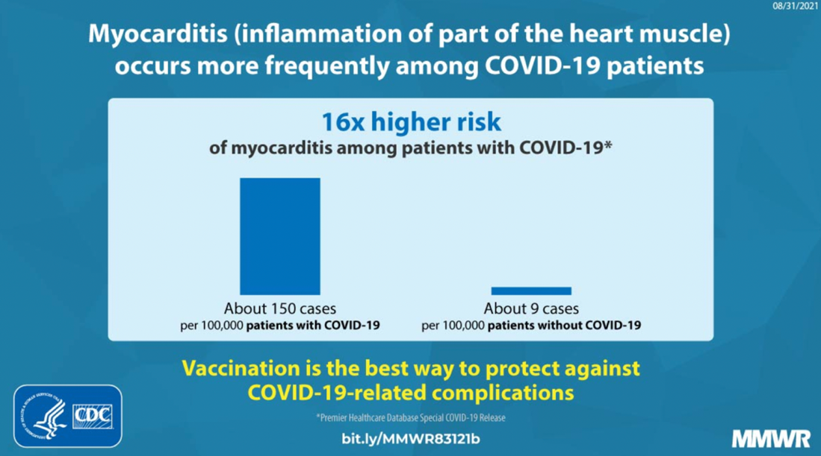
Note. Graphic from the Centers for Disease Control and Prevention (CDC) Morbidity and Mortality Weeky Report (MMWR) (Boehmer et al., 2021).

Examples of “Bad” Visualizations

Poor visualizations can easily mislead the public. Among many, common data visualization follies include cluttered numbers and graphics, the use of pie charts, missing context, unclear labelling, and poor colour and shading choices. Figure 2 depicts an example of a visualization with missing context (Foley, 2020). This graphic, created by the Arkansas Department of Health, shows the rate of preexisting health conditions in patients with COVID-19. Since the percentages are low and the scale goes up to 100 percent, it seems like having another condition like hypertension may not be that serious. However, research suggests that individuals with preexisting health conditions are more likely to experience severe cases of COVID-19 (Treskova-Schwarzbach et al., 2021). When this graphic was created, Arkansas had approximately 17,000 cases, which means that over 1,700 people who had COVID-19 may also have had hyperthension, and therefore were at risk of having a more severe case that could result in death (Foley, 2020). Yet, without this context, the data and information presented in the visualization is meaningless and misleading.

Figure 2
Rate of Preexisting Health Conditions in Patients with COVID-19
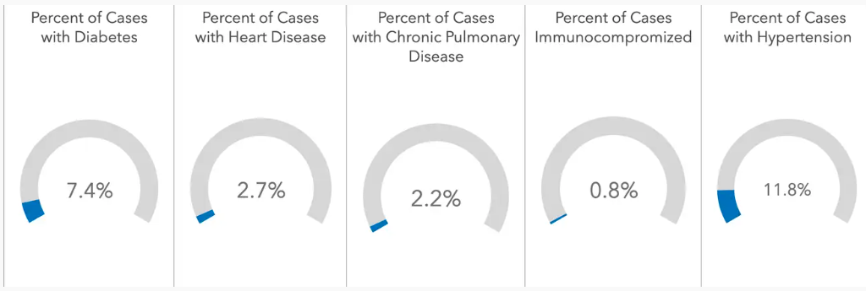
Note. Graphic taken from Foley, 2020.

Used properly, colour can make it easier for the audience to understand the information you are communicating. As outlined by van Biljon & Osei-Bryson (2020), colours should be used to support the relating and differentiating aspects of the visualization. The context of the visualization should also be considered since colours have different meanings in different contexts and cultures. When colour is used incorrectly, it can cause confusion and be misleading. Some common issues that arise when incorporating colour into visualizations include using too many colours, using familiar colours (e.g., red and green) in surprising ways, using colours with little contrast, and not accounting for viewers who may be colourblind (Stobierski, 2021). Figure 3 provides an example of improper colour use. This figure depicts a US map chart showing virus infection rates from state to state, with colours representing different concentrations of positive cases. Typically, map charts leverage different shades within the same colour family. For instance, the lighter the shade, the fewer the cases in that state, and the darker the shade, the more cases in that state. However, this example is going against this assumption and uses a darker red colour to indicate fewer cases. Although not inherently wrong, using colour in this surprising way may confuse the viewer and decrease the impact of the visualization.

Figure 3
US Map Depicting COVID-19 Virus Infection Rates from State to State
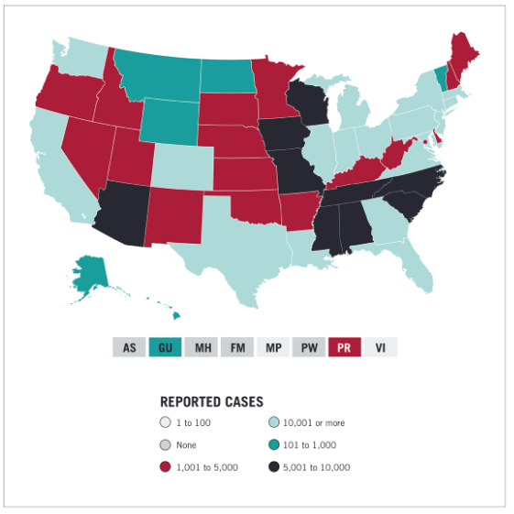
Note. Graphic taken form Stobierski, 2021.

Conclusions and Future Directions

The current paper highlighted the importance of using knowledge visualization for health-related knowledge translation. In this current age of misinformation, it is important to leverage simple and accessible visualizations when communicating evidence-based scientific knowledge. Effective dissemination of health-related research findings via social media platforms relies heavily on the use of graphics to summarize the data. Altmetric is a tool used to track online engagement to reveal how and where research is making an impact (Altmetric, 2023). Currently, Altmetric is solely used to quantify the impact research articles and reports make. Future research should examine how we can leverage such tools to track the impact of graphics and data visualization techniques for KT. Moreover, studies should investigate whether certain design criteria increase or decrease the impact visualizations make across different social media platforms. Understanding this impact could pave the way for improving KT, ultimately increasing health literacy and decreasing the proliferation of misinformation.

References
Abudiyab, N. A., & Alanazi, A. T. (2022). Visualization techniques in healthcare applications: A narrative review. Cureus, 14(11), e31355. https://doi.org/10.7759/cureus.31355
Altmetric. (2023). What are altmetrics? https://www.altmetric.com/about-us/what-are-altmetrics/
Boehmer, T. K., Kompaniyets, L., Lavery, A. M., Hsu, J., Jo, J. Y., Yusuf, H., Romano, S. D., Gundlapalli, A. V., Oster, M. E., & Harris, A. M. (2021). Association between COVID-19 and myocarditis using hospital-based administrative data—United States, March 2020–January 2021. MMWR. Morbidity and Mortality Weekly Report, 70. https://doi.org/10.15585/mmwr.mm7035e5
Burkhard, R. A. (2005). Towards a framework and a model for knowledge visualization: Synergies between information and knowledge visualization. In S.-O. Tergan & T. Keller (Eds.), Knowledge and Information Visualization: Searching for Synergies (pp. 238–255). Springer. https://doi.org/10.1007/11510154_13
Chou, W.-Y. S., Oh, A., & Klein, W. M. P. (2018). Addressing health-related misinformation on social media. JAMA, 320(23), 2417–2418. https://doi.org/10.1001/jama.2018.16865
Foley, K. E. (2020, June 25). How bad Covid-19 data visualizations mislead the public. Quartz. https://qz.com/1872980/how-bad-covid-19-data-visualizations-mislead-the-public
Funk, S., Gilad, E., Watkins, C., & Jansen, V. A. A. (2009). The spread of awareness and its impact on epidemic outbreaks. Proceedings of the National Academy of Sciences, 106(16), 6872–6877. https://doi.org/10.1073/pnas.0810762106
Gavrilova, T., Alsufyev, A., & Grinberg, E. (2017). Knowledge visualization: Critique of the St. Gallen School and an analysis of contemporary trends. Business Informatics, 41(3), 7–19. https://doi.org/10.17323/1998-0663.2017.3.7.19
Grimshaw, J. M., Eccles, M. P., Lavis, J. N., Hill, S. J., & Squires, J. E. (2012). Knowledge translation of research findings. Implementation Science, 7(1), 50. https://doi.org/10.1186/1748-5908-7-50
Kim, S. J., Han, J. A., Lee, T.-Y., Hwang, T.-Y., Kwon, K.-S., Park, K. S., Lee, K. J., Kim, M. S., & Lee, S. Y. (2014). Community-based risk communication survey: Risk prevention behaviors in communities during the H1N1 crisis, 2010. Osong Public Health and Research Perspectives, 5(1), 9–19. https://doi.org/10.1016/j.phrp.2013.12.001
Kirk, A. (2016). Data visualisation: A handbook for data driven design (2nd ed.). Sage.
Levin, B. (2008, August). Thinking about knowledge mobilization. A discussion paper prepared at the request of the Canadian Council on Learning and the Social Sciences and Humanities Research Council. https://www.sshrc-crsh.gc.ca/about-au_sujet/publications/KMb_-_LevinDiscussionPaper_-_E.pdf
Levy, J. A., & Strombeck, R. (2002). Health benefits and risks of the Internet. Journal of Medical Systems, 26(6), 495–510. https://doi.org/10.1023/a:1020288508362
McKibbon, K. A., Lokker, C., Wilczynski, N. L., Ciliska, D., Dobbins, M., Davis, D. A., Haynes, R. B., & Straus, S. E. (2010). A cross-sectional study of the number and frequency of terms used to refer to knowledge translation in a body of health literature in 2006: A Tower of Babel? Implementation Science: IS, 5, 16. https://doi.org/10.1186/1748-5908-5-16
Meyer, R. (2010). Knowledge visualization. Trends in Information Visualization, 23, 23-30. https://doi.org/10.1007/978-1-4471-4303-1
Opiła, J. (2019). Role of visualization in a knowledge transfer process. Business Systems Research Journal, 10(1), 164–179.
Social Sciences and Humanities Research Council. (2023, November 11). Guidelines for effective knowledge mobilization. Government of Canada. https://www.sshrc-crsh.gc.ca/funding-financement/policies-politiques/knowledge_mobilisation-mobilisation_des_connaissances-eng.aspx
Stobierski, T. (2021, January 28). Bad data visualization: 5 examples of misleading data. Harvard Business School Online. https://online.hbs.edu/blog/post/bad-data-visualization
Suarez-Lledo, V., & Alvarez-Galvez, J. (2021). Prevalence of health misinformation on social media: Systematic review. Journal of Medical Internet Research, 23(1). https://doi.org/10.2196/17187
Tetroe, J. M., Graham, I. D., Foy, R., Robinson, N., Eccles, M. P., Wensing, M., Durieux, P., Légaré, F., Nielson, C. P., Adily, A., Ward, J. E., Porter, C., Shea, B., & Grimshaw, J. M. (2008). Health research funding agencies’ support and promotion of knowledge translation: An international study. The Milbank Quarterly, 86(1), 125–155. https://doi.org/10.1111/j.1468-0009.2007.00515.x
Treskova-Schwarzbach, M., Haas, L., Reda, S., Pilic, A., Borodova, A., Karimi, K., Koch, J., Nygren, T., Scholz, S., Schönfeld, V., Vygen-Bonnet, S., Wichmann, O., & Harder, T. (2021). Pre-existing health conditions and severe COVID-19 outcomes: An umbrella review approach and meta-analysis of global evidence. BMC Medicine, 19(21), 1-16. https://doi.org/10.1186/s12916-021-02058-6
van Biljon, J., & Osei-Bryson, K.-M. (2020). The communicative power of knowledge visualizations in mobilizing information and communication technology research. Information Technology for Development, 26(4), 637–652. https://doi.org/10.1080/02681102.2020.1821954
Vosoughi, S., Roy, D., & Aral, S. (2018). The spread of true and false news online. Science, 359(6380), 1146–1151. https://doi.org/10.1126/science.aap9559
Xiong, F., & Liu, Y. (2014). Opinion formation on social media: An empirical approach. Chaos: An Interdisciplinary Journal of Nonlinear Science, 24(1), 013130. https://doi.org/10.1063/1.4866011

