The Effectiveness of Data Visualizations in Facilitating Informed Decision-Making Processes During Pregnancy

Adina Levi
Department of Psychology, York University
PSYC 6135: Psychology of Data Visualization
Dr. Michael Friendly
May 15, 2024

The Effectiveness of Data Visualizations in Facilitating Informed Decision-Making Processes During Pregnancy

Background and Relevant Research: Using the Internet as a primary source for health-related inquiries has become increasingly prevalent in both the United States and Europe (Sadasivam et al., 2013; Statista, 2018). Statistics reveal that approximately 73.5% of Internet users engage in health-related research, with a positive correlation observed between Internet usage and educational attainment (Turkish Statistical Institute, 2018). Advancements in information technology have empowered individuals to actively manage their health and participate in decision-making processes (Bass et al., 2006). The motivation for seeking medical information online is often rooted in personal experiences with diseases or health issues. Moreover, various factors, including pregnancy, demographic attributes, socioeconomic status, educational background, occupation, and personal attitudes, influence individuals’ behaviours regarding health information seeking on the Internet (Sadasivam et al., 2013; Statista, 2018).
Data visualization plays a pivotal role in enhancing comprehension of intricate real-world issues by amalgamating extensive data from diverse sources and highlighting patterns and trends that are otherwise difficult to perceive. This renders information more accessible and alleviates cognitive load, ultimately fostering effective decision-making processes (Dolan et al., 2013; Larson & Edsall, 2010; Rudolph et al., 2009; Savikhin et al., 2008). Broadly defined, visualization encompasses various visual representations of data and information, such as charts, graphs, maps, images, and infographics, which facilitate understanding and communication (Park, 2019). Well-designed visualizations facilitate the exploration of unfamiliar data (i.e., data that may be new or difficult to understand without the aid of visual representations) and address inquiries regarding real-world challenges. Previous experimental research has demonstrated that data supplemented with visualization tools significantly influences human understanding, perception, motivation, attitude, and decision-making (Kim, 2018; Samek et al., 2016; Telea, 2014; Thai et al., 2014). For instance, a study investigating the efficacy of visualization tools in aiding emergency unit staff revealed that those presented with visualized maps exhibited heightened situational awareness and confidence in their comprehension compared to those relying on tables (Thai et al., 2014). Consistent with these findings, insights from a qualitative study underscored the utility of data visualization in public health practice, as practitioners highlighted its efficacy in understanding and conveying data based on their professional experiences (Park, 2019).
Understanding the impact of data visualization in health-related decision-making processes is particularly crucial in the context of pregnancy, a pivotal phase in a woman's life. It presents a unique opportunity to address health literacy and promote informed decision-making. It serves as a period when women are often motivated to adopt healthier behaviours and are exposed to various sources of health information and services, including guidance from prenatal healthcare providers and online resources (Larson & Edsall, 2010). Prior research has highlighted the link between inadequate health literacy and several pregnancy-related factors, such as knowledge gaps, suboptimal health behaviours, and adverse outcomes, including issues like insufficient prenatal care, challenges in managing chronic conditions, and difficulties in family planning (Dolan et al., 2013; Samek et al., 2016; Savikhin et al., 2008; Rudolph et al., 2009). However, there remains a gap in understanding how different aspects of health literacy influence women's experiences and decision-making processes concerning prenatal care.
Previous research indicates that pregnant women heavily rely on the Internet as their primary source of information and guidance during pregnancy, significantly influencing their decision-making processes (Bert et al., 2013; Criss et al., 2015; Hämeen-Anttila et al., 2014; Hinton et al., 2018; Huberty et al., 2013; Jacobs et al., 2019; Lagan et al., 2010; Narasimhulu et al., 2016). With usage rates ranging from 70% to 97%, pregnant women turn to the Internet for various purposes, including accessing pregnancy-related information, validating advice from healthcare providers, engaging in social networking, and seeking support (Bjelke et al., 2016; Huberty et al., 2013; Narasimhulu et al., 2016; Scaioli et al., 2015). As well, this reliance on the Internet extends to accessing information on pregnancy-related products, seeking second opinions, alleviating anxiety, enhancing knowledge, and participating in online discussions (Bert et al., 2013; Huberty et al., 2013; Lagan et al., 2010). A notable finding from a study involving pregnant women revealed that the Internet significantly influenced their decision-making processes, often due to perceived gaps in information provided by healthcare professionals and limited opportunities for direct communication with them (Lagan et al., 2010). Reasons for relying on the Internet include dissatisfaction with the clarity and adequacy of information provided by healthcare providers, as well as time constraints limiting direct interactions with healthcare professionals (Lagan et al., 2010; Wallwiener et al., 2016). The Internet's appeal lies in its accessibility and anonymity, particularly in situations where accessing medical advice through traditional channels poses challenges (Narasimhulu et al., 2016). It is imperative that pregnant women have access to evidence-based information to facilitate informed decision-making (Lagan et al., 2011).
The following examples demonstrate the Internet's efficacy in influencing the decisions of pregnant women: In a UK study, half of the pregnant women who had previously used at least one medication (either vitamin or non-mineral) discontinued usage upon pregnancy due to their online research findings (Sinclair et al., 2018). Similarly, research conducted in Portugal revealed that Internet-derived information influenced pregnant women's decisions regarding prenatal screening tests and delivery methods (Ferraz et al., 2016). Huberty et al. (2013) observed heightened self-assurance among pregnant women regarding physical activity and dietary choices post-Internet use. An Australian pregnant woman benefited from fellow expectant mothers' experiences shared on forums when selecting a physician, while another in the UK, grappling with uncertainty about a 16-week triple test, found ample information online to inform her decision-making (Lagan et al., 2011). In the UK, pregnant women regularly utilize the Internet in the final trimester to determine their birthing location (Hinton et al., 2018). Wallwiener et al. (2016) surveyed pregnant women regarding the impact of web-based information on their decision-making processes during pregnancy, revealing significant associations between various Internet sources (e.g., e-Health/medical web pages, web forums, mHealth/smartphone applications) and decision-making. These examples highlight the Internet's impact on pregnant women's choices regarding health-related decisions.
Conversely, Lagan et al. (2011) conducted a qualitative inquiry into the adverse ramifications of Internet usage on pregnant women's decision-making processes. For example, social media and networking site information negatively influenced decisions regarding whooping cough vaccination during pregnancy, as found in another UK study (Ford & Alwan, 2018). As well, numerous expectant mothers expressed experiencing unnecessary anxiety upon encountering worst-case scenarios related to pregnancy complications online, with some describing the information as "frightening." While most pregnant women exercise caution by assessing specific criteria to gauge the reliability of Internet information, such as website authorship, Uniform Resource Locator (URL), currency, and accuracy (Lagan et al., 2010), a considerable proportion (65%) encountered misleading or erroneous content on websites they accessed for information (Huberty et al., 2013). Some studies revealed that while pregnant women sought advice from healthcare professionals based on Internet findings, they often omitted disclosing their information sources (Ferraz et al., 2016; Shorten et al., 2015). These behaviours suggest a simultaneous reliance on and distrust of Internet information among pregnant women. Enhancing the quality of Internet resources with accurate and dependable information stands as a critical imperative for healthcare providers, given pregnant women's keen interest in diverse information sources (Jacobs et al., 2019; Wallwiener et al., 2016).
As well, a systematic review highlights concerns regarding the quality, timeliness, and accuracy of online information, particularly in the context of pregnancy-related decision-making. Pregnant women often grapple with uncertainty and heightened anxiety due to a lack of trust in the information sourced from the Internet (Sayakhot & Carolan-Olah, 2016). Exploring the impact of online data visualizations on decision-making processes during pregnancy presents a valuable opportunity for healthcare professionals to better assist pregnant women. Understanding the usage patterns and motivations behind pregnant women's reliance on online data visualizations is essential for healthcare practitioners to tailor their services effectively and curate dependable online resources (Lagan et al., 2010). These insights can significantly contribute to the development of informed decision-making strategies aimed at improving the well-being of pregnant women.
Pregnant women navigate a diverse array of online information sources, ranging from scholarly articles to more user-friendly platforms. While peer-reviewed literature offers robust evidence, its complexity may pose accessibility challenges for those lacking a research background (Whitehead & Maude, 2013). Consequently, many pregnant women turn to search engines like Google for pregnancy-related inquiries (Conrad, 2024). Alternatively, "peer-reviewed websites" present scholarly information in a digestible manner (e.g., Centers for Disease Control and Prevention, 2020), while popular websites may lack such rigour (Link et al., 2017). Despite this diversity, data visualizations are a common thread across these resources. This study explores how pregnant women interact with, interpret, and apply health information throughout pregnancy, specifically examining the effectiveness of data visualizations in communicating actionable insights. Understanding the impact of these varied sources is crucial for ensuring pregnant women have access to accurate and reliable information for informed healthcare decisions.

Study Aim: The proposed research aims to explore how data visualizations influence decision-making processes among pregnant women seeking healthcare advice. To achieve this, the study will include a detailed comparative analysis of data visualizations sourced from three distinct categories:

- Peer-reviewed research studies: These visualizations originate from scientific studies that have undergone rigorous peer review, ensuring accuracy and reliability. They offer detailed insights into pregnancy-related health issues based on empirical data, representing the gold standard in scientific research. However, their technical nature and reliance on statistical analysis may limit accessibility to the general public. While peer-reviewed articles provide the most credible evidence, their complex technical information and scientific jargon can pose accessibility challenges among non-experts. Further, many of these peer-reviewed articles are often inaccessible due to paywalls, exacerbating issues related to accessibility.

Example: Suppose a woman discovers she is pregnant and wonders if she can still have her hot cup of coffee in the morning. Aware of the potential caffeine restrictions, she seeks expert advice online. She comes across a data visualization in a research paper depicting the link between maternal caffeine consumption during pregnancy and its relative risk to the baby's health, particularly regarding low birth weight (Jin & Qiao, 2020). The paper describes a dose-response meta-analysis that revealed that for every 100mg/day increase in maternal caffeine intake during pregnancy, there was a slight increase in the risk of low birth weight, with a pooled Relative Risk of 1.07 (95% CI: 1.02, 1.11). However, without familiarity with understanding and interpreting research articles and statistical terminology, the graph's key message may not be readily apparent. Further, the absence of a legend indicating the representation of the different graph linotypes presents another obstacle, potentially requiring pregnant women to review the full article to assist graph comprehension.

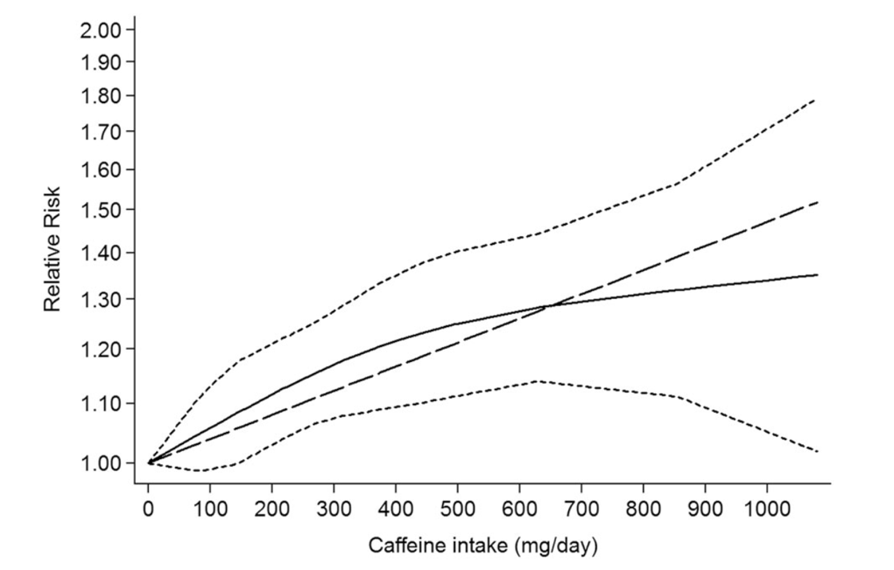
Figure 1. Dose-response meta-analysis depicting the association between maternal caffeine intake during pregnancy and the risk of low birth weight, sourced from Jin and Qiao (2020).

- Reputable websites referencing peer-reviewed papers: Visualizations from these sources are typically based on information obtained from peer-reviewed research studies. While not directly sourced from the original data, they provide a bridge between scientific research and public understanding. Websites like the Centers for Disease Control and Prevention (CDC) or the American College of Obstetricians and Gynecologists (ACOG) website compile and interpret data from peer-reviewed literature, presenting it in a more accessible format for a broader audience. These visualizations may offer a balance between scientific rigour and user-friendliness.

Example: The CDC (2021). Pregnancy during the COVID-19 pandemic introduced unique hurdles for expectant mothers. Imagine a scenario where a pregnant woman learns about the newly developed COVID-19 vaccine from her family and friends and seeks advice from her family doctor. Though her doctor recommends the vaccine, she's apprehensive about potential risks to her baby. After consulting her physician, she decides to research the vaccine's pros and cons during pregnancy online. During her search, she encounters a CDC visualization. Despite the inexcusable chartjunk, the visualization illustrates the heightened risk of severe illness and mortality from COVID-19 among pregnant women. This prompts her to prioritize vaccination and preventive measures for the safety of both her and her baby. While the visualization is not directly from a peer-reviewed study, the data is, and the CDC's visualization remains accessible to the public and aids in informed decision-making.

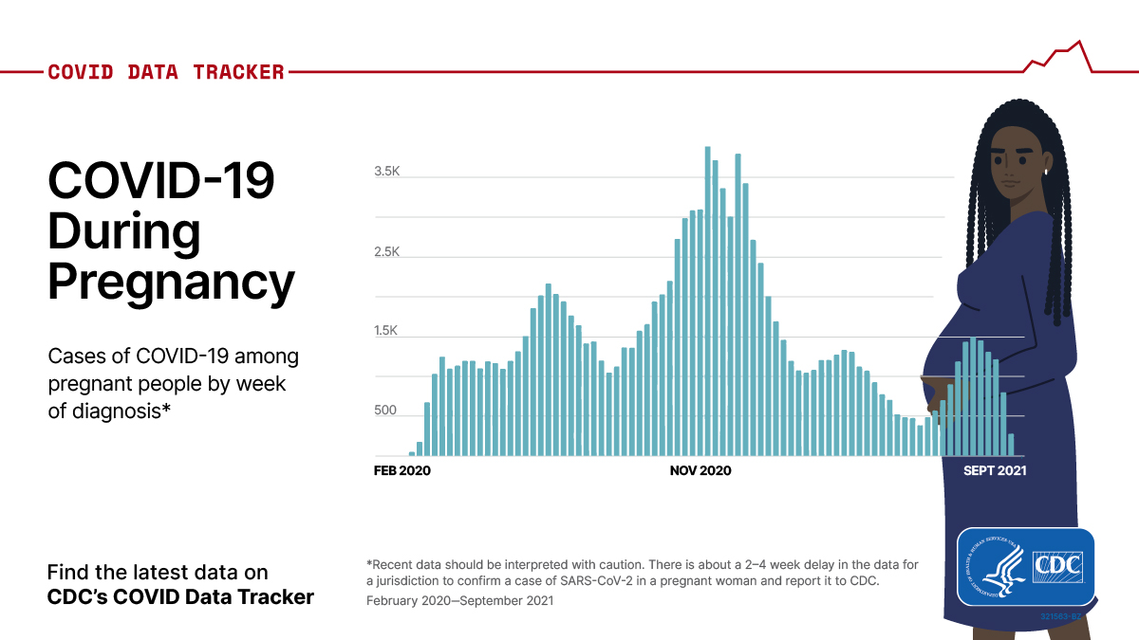

Figure 2. Visualization from the CDC.gov website on health and safety updates, noting that pregnant and recently pregnant women face higher risks of severe illness and mortality from COVID-19. They note that with over 120,000 cases reported since February 22, 2020, vaccination and protective measures are crucial for safeguarding both maternal and fetal health (CDC, 2021).

- Popular pregnancy-related websites, blogs, and anecdotes: Visualizations from these sources are often anecdotal or based on personal experiences rather than scientific evidence. Although they may provide insights into common pregnancy-related concerns and experiences, they may lack scientific rigour and validity. These visualizations can vary widely in quality, with some offering valuable insights and others potentially promoting misinformation or myths. While these sources may offer accessible and user-friendly information, they may also present conflicting or unsubstantiated claims, potentially leading to confusion or misinformation among pregnant women.

Example: Suppose a woman in her first trimester is navigating the complexities of dietary choices. Seeking guidance, she turns to her trusted source, Femina, a popular Indian lifestyle and entertainment website catering to women's interests. Femina covers a broad spectrum of topics, including health and wellness, offering articles, blogs, videos, and galleries. On the website, she discovers a visually appealing visualization categorizing the food that pregnant women should or should not eat into "good" and "bad" categories. While the visualization is easy to comprehend, its scientific basis remains unclear, lacking references to external research (Dubey, 2020). Despite this, the woman places trust in the website, potentially overlooking the absence of scientific validation. While the visualization may offer generally sound advice, experts might question certain aspects, such as recommendations regarding specific foods. For instance, sea fish is classified as "good," but this categorization may be contested by healthcare professionals due to variations in mercury levels (Chen & Dong, 2022). Therefore, although visually accessible, relying solely on this kind of source for prenatal health decisions may not provide the most reliable information.

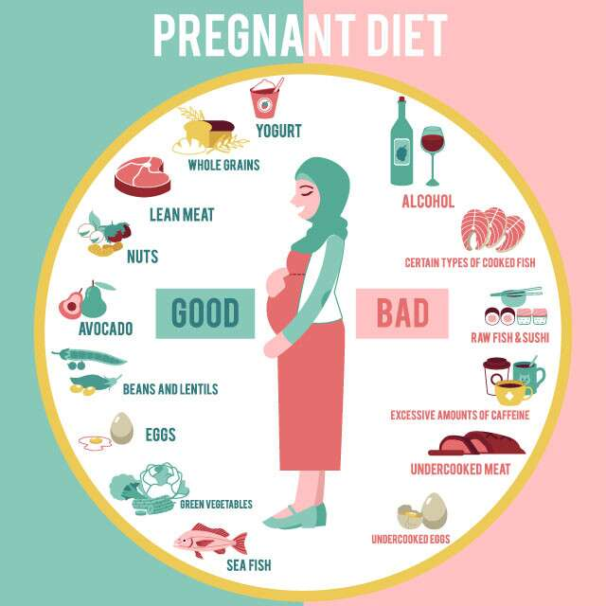

Figure 3. Visualization illustrating dietary restrictions for pregnant women sourced from Femina.in (Dubey, 2020).

Study Hypotheses: The effectiveness of data visualizations in aiding decision-making processes among pregnant women regarding healthcare advice varies based on the source of the visualizations. Specifically, we hypothesize that visualizations from peer-reviewed research studies will be perceived as the most accurate and reliable, albeit potentially less accessible and understandable. On the other hand, visualizations from reputable websites that reference peer-reviewed papers may strike a balance between clarity and accessibility. As well, popular pregnancy-related websites, blogs, and anecdotes may be more accessible but vary in accuracy. We further hypothesize that the accessibility, comprehensibility, and perceived effectiveness of data visualizations will influence pregnant women's decision-making processes regarding healthcare advice. Visualizations from reputable sources may be perceived as more trustworthy and influential compared to those from less reliable sources.

Study Design: The research will employ a mixed-methods approach. It will incorporate both quantitative and qualitative methods to investigate the effectiveness of data visualizations in aiding current decision-making processes among pregnant women regarding health-related decisions. This approach allows for a comprehensive exploration of the research questions, offering insights into both the quantitative trends and qualitative nuances of pregnant women's experiences.

Participant Recruitment: Participants will be recruited through various channels, including online forums, social media platforms, and healthcare facilities specializing in prenatal care. Eligibility criteria will include being pregnant or having been pregnant within the past year, being proficient in English, and having access to the Internet. Recruitment strategies will prioritize diversity in terms of demographics, including age, education, socioeconomic status, and geographic location, to ensure the study captures a wide range of perspectives.

Data Collection: Data collection will involve two main components: surveys and semi-structured interviews.
Surveys: A structured online survey will be administered to participants to gather quantitative data on their preferences, comprehension levels, and decision-making processes when presented with different data visualizations. The survey will include Likert-scale, multiple-choice, and open-ended questions to capture qualitative insights.
Semi-Structured Interviews: Semi-structured interviews will be conducted with a subset of participants to explore their experiences in more depth. Interviews will be audio-recorded and transcribed to facilitate data analysis. Participants will be asked to discuss their perceptions of the visualizations, including their ease of understanding, relevance to their decision-making process, and overall effectiveness in conveying pregnancy-related healthcare advice.

Visual Stimuli: Visual stimuli will consist of data visualizations sourced from three distinct categories: (1) peer-reviewed research studies, (2) reputable websites referencing peer-reviewed papers, and (3) popular pregnancy-related websites, blogs, and anecdotes. Visualizations will be selected to represent a range of topics relevant to prenatal healthcare (e.g., dietary changes, physical restrictions, prenatal healthcare, etc.).

Proposed Statistical Analyses: The proposed statistical analyses for the paper will involve a combination of quantitative and qualitative methods to comprehensively explore the impact of data visualizations on decision-making processes among pregnant women. Quantitative analyses will include descriptive statistics to summarize participant demographics and survey responses. Inferential statistics, such as chi-square tests or logistic regression, will assess associations between variables, such as the type of Internet-based resource accessed and decision-making outcomes. Decision-making outcomes may involve identifying the effectiveness and comprehensibility of specific visualizations sourced from various internet-based platforms, which could influence the actions taken by pregnant women based on the visual information. For example, participants may indicate whether they would follow advice found online, specifying the source of information they relied on (one of the three options given to them), which could influence decisions such as selecting a prenatal vitamin or choosing between obstetrics or midwifery care. The inferential statistics mentioned, such as chi-square tests or logistic regression, would help analyze the associations between variables like the type of internet-based resource accessed (e.g., peer-reviewed articles, online forums, reputable websites) and these decision-making outcomes. Additionally, multivariate analysis and dimension-reduction techniques, such as principal component analysis (PCA), may be employed to identify underlying clusters in the data. Qualitative analysis will involve thematic coding of interview transcripts to highlight the nuanced perspectives and experiences of pregnant women regarding the accessibility, comprehensibility, and effectiveness of data visualizations. The integration of both quantitative and qualitative findings will provide a comprehensive understanding of how different types of Internet-based data visualizations influence decision-making processes during pregnancy.

Hypothesized Results: Several outcomes are anticipated based on the nature of the visualizations and their sources. Firstly, it is expected that data visualizations sourced from peer-reviewed research studies would be perceived as the most accurate and reliable by pregnant women. Given the rigorous scrutiny and validation inherent in the peer review process, these visualizations are likely to provide credible and evidence-based information. However, due to their technical nature and reliance on statistical analysis, they may be perceived as less accessible and understandable compared to visualizations from other sources.
On the other hand, visualizations sourced from reputable websites referencing peer-reviewed papers (e.g., CDC) may strike a balance between accuracy and accessibility. These visualizations are expected to be perceived as trustworthy and reliable, as they are based on information derived from peer-reviewed research studies. However, they may be presented in a more user-friendly format, making them easier for pregnant women to comprehend and interpret compared to visualizations from peer-reviewed research studies directly.
In contrast, visualizations from popular pregnancy-related websites, blogs, and anecdotes may vary widely in accuracy and reliability. While some visualizations from these sources may provide valuable insights and support, others may promote misinformation or myths. It is anticipated that pregnant women may perceive visualizations from these sources as more accessible and relatable, given their informal and user-friendly nature. However, their accuracy and reliability may be questionable, leading to potential confusion or misinformation among pregnant women.

Significance: This study holds importance as it seeks to bridge the gap in understanding how pregnant women navigate the wealth of online health information, particularly through data visualizations, to inform their healthcare decisions. Given the pivotal role of prenatal care in maternal and infant health outcomes, understanding the impact of various Internet-based resources on decision-making processes is crucial. This research aims to comprehensively examine the accessibility, comprehensibility, and effectiveness of data visualizations sourced from different online platforms. The aim is to offer valuable insights into how pregnant women utilize online health information, specifically through data visualizations, to inform their healthcare decisions. This research seeks to enhance the quality of prenatal care delivery and improve health outcomes for both mothers and infants.
While physician consultation may be deemed the most trustworthy source of information for pregnant women, the majority still turn to the Internet for information gathering and decision-making processes. In Canada, accessing primary care physicians or specialists (i.e., obstetricians) can often be challenging, with long wait times and limited availability (Marshall et al., 2022). This difficulty in securing timely medical appointments can leave pregnant women with few alternatives beyond seeking information online. Similarly, in the United States, where healthcare costs are prohibitively high for many individuals, access to medical professionals is often restricted, prompting many pregnant women to turn to online resources for guidance and support (Dolin et al., 2021). As a result, the Internet has become a crucial avenue for accessing information, advice, and support related to pregnancy and prenatal care for women in both countries (Snyder et al., 2020). Further, this observation aligns with the findings of a recent review, with many studies reporting that pregnant women utilized the Internet in this capacity (Ahman et al., 2016; Bert et al., 2013; Bjelke et al., 2016; Criss et al., 2015; Ferraz et al., 2016; Ford & Alwan, 2018; Fredriksen et al., 2016; Hämeen-Anttila et al., 2014; Hinton et al., 2018; Huberty et al., 2013; Jacobs et al., 2019; Lagan et al., 2010, 2011; McArdle et al., 2015; Narasimhulu et al., 2016; Shorten et al., 2015; Sinclair et al., 2018; Wallwiener et al., 2016). Consequently, the Internet emerges as a primary source of information for pregnant women and often serves as the primary means of information access. The widespread usage of the Internet among pregnant women underscores the heightened need for information and assistance within this demographic (Fredriksen et al., 2016). Utilizing the Internet empowers pregnant women to pinpoint queries they wish to address, engage in decision-making processes, enhance decision quality, and assert greater autonomy over their choices (Lagan et al., 2010).
This research topic is essential, specifically addressing how data visualizations on the Internet shape the decisions of pregnant women. It not only highlights how online information influences pregnant women but also addresses their lingering uncertainties post-consultation with healthcare providers. By interpreting health-related data visualizations, pregnant women can make informed decisions and enhance their overall well-being, acknowledging the Internet's crucial role in facilitating health information retrieval and decision-making processes, as demonstrated in prior research (Lagan et al., 2010). This study holds implications for both healthcare providers and pregnant women, aiming to underscore the significance of data visualizations in informing healthcare decisions during pregnancy. Through an examination of visualizations from various platforms, including peer-reviewed research studies, reputable websites, and popular pregnancy-related sources, the study offers insights into how pregnant women perceive and utilize healthcare information. Potential findings could inform healthcare communication strategies, guiding the design and presentation of visual information tailored to pregnant women's needs. Understanding which visualizations aid decision-making processes can assist healthcare providers in supporting expectant mothers to make better-informed choices about their prenatal care. Furthermore, by delineating the strengths and limitations of different information sources, the study may empower pregnant women to critically evaluate healthcare advice and navigate online information effectively, potentially enhancing healthcare outcomes and the quality of prenatal care delivery.

(Finally, in the course of my research for this paper, I stumbled upon this visualization (Misgav, 2021). While it's not directly pertinent to our topic, I found it to be a perfect visual summary of the pregnancy and postpartum period 😊).

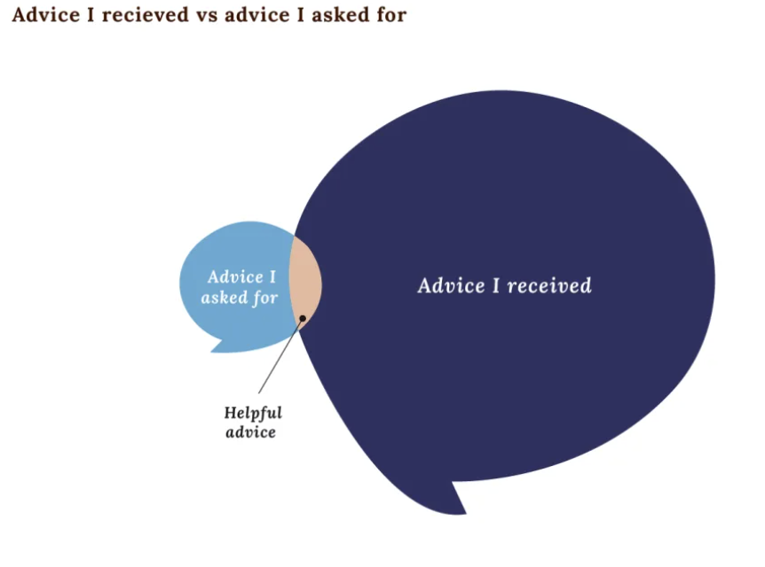

References

Ahman, A., Sarkadi, A., Lindgren, P., & Rubertsson, C. (2016). ‘It made you think twice’–an interview study of women’s perception of a web-based decision aid concerning screening and diagnostic testing for fetal anomalies. BMC Pregnancy and Childbirth, 16, 1-10.
Bass, S. B., Ruzek, S. B., Gordon, T. F., Fleisher, L., McKeown-Conn, N., & Moore, D. (2006). Relationship of Internet health information use with patient behavior and self-efficacy: experiences of newly diagnosed cancer patients who contact the National Cancer Institute's Cancer Information Service. Journal of Health Communication, 11(2), 219-236.
Bert, F., Gualano, M. R., Brusaferro, S., De Vito, E., De Waure, C., La Torre, G., ... & Siliquini, R. (2013). Pregnancy e-health: a multicenter Italian cross-sectional study on Internet use and decision-making among pregnant women. Journal of Epidemiology Community Health, 67(12), 1013-1018.
Bjelke, M., Martinsson, A. K., Lendahls, L., & Oscarsson, M. (2016). Using the Internet as a source of information during pregnancy—A descriptive cross-sectional study in Sweden. Midwifery, 40, 187-191.
Centers for Disease Control (CDC). (2021, September 21). COVID-19 Data Tracker: Pregnant Population. Retrieved from https://covid.cdc.gov/covid-data-tracker/#pregnant-population
Chen, B., & Dong, S. (2022). Mercury contamination in fish and its effects on the health of pregnant women and their fetuses, and guidance for fish consumption—a narrative review. International Journal of Environmental Research and Public Health, 19(23), 15929.
Conrad, M. (2024). Health information-seeking internet behaviours among pregnant women: a narrative literature review. Journal of Reproductive and Infant Psychology, 42(2), 194-208.
Criss, S., Woo Baidal, J. A., Goldman, R. E., Perkins, M., Cunningham, C., & Taveras, E. M. (2015). The role of health information sources in decision-making among Hispanic mothers during their children’s first 1000 days of life. Maternal and Child Health Journal, 19, 2536-2543.
Dolan, J. G., Veazie, P. J., & Russ, A. J. (2013). Development and initial evaluation of a treatment decision dashboard. BMC Medical Informatics and Decision making, 13, 1-9.
Dolin, C. D., Compher, C. C., Oh, J. K., & Durnwald, C. P. (2021). Pregnant and hungry: addressing food insecurity in pregnant women during the COVID-19 pandemic in the United States. American Journal of Obstetrics & Gynecology MFM, 3(4), 100378.
Dubey, 2020. Femina. Pregnancy diet chart. Retrieved from https://www.femina.in/relationships/parenting/pregnancy-diet-chart-165681.html
Ferraz, M., Almeida, A. M., Matias, A., & Farine, D. (2016). The influence of the web on health related decision-making processes: a survey with Portuguese women during pregnancy. Procedia Computer Science, 100, 347-354.
Ford, A. J., & Alwan, N. A. (2018). Use of social networking sites and women's decision to receive vaccinations during pregnancy: a cross-sectional study in the UK. Vaccine, 36(35), 5294-5303.
Fredriksen, E. H., Harris, J., & Moland, K. M. (2016). Web-based discussion forums on pregnancy complaints and maternal health literacy in Norway: a qualitative study. Journal of Medical Internet Research, 18(5), e113.
Hämeen-Anttila, K., Nordeng, H., Kokki, E., Jyrkkä, J., Lupattelli, A., Vainio, K., & Enlund, H. (2014). Multiple information sources and consequences of conflicting information about medicine use during pregnancy: a multinational Internet-based survey. Journal of Medical Internet Research, 16(2), e60.
Hinton, L., Dumelow, C., Rowe, R., & Hollowell, J. (2018). Birthplace choices: what are the information needs of women when choosing where to give birth in England? A qualitative study using online and face to face focus groups. BMC Pregnancy and Childbirth, 18, 1-15.
Huberty, J., Dinkel, D., Beets, M. W., & Coleman, J. (2013). Describing the use of the internet for health, physical activity, and nutrition information in pregnant women. Maternal and Child Health Journal, 17, 1363-1372.
Jacobs, E. J., van Steijn, M. E., & van Pampus, M. G. (2019). Internet usage of women attempting pregnancy and pregnant women in the Netherlands. Sexual & Reproductive Healthcare, 21, 9-14.
Jin, F., & Qiao, C. (2021). Association of maternal caffeine intake during pregnancy with low birth weight, childhood overweight, and obesity: a meta-analysis of cohort studies. International Journal of Obesity, 45(2), 279-287.
Marshall, E. G., Wuite, S., Lawson, B., Andrew, M. K., Edwards, L., MacKenzie, A., ... & Peddle, S. (2022). “What do you mean I can’t have a doctor? this is Canada!”–a qualitative study of the myriad consequences for unattached patients awaiting primary care attachment. BMC Primary Care, 23(1), 60.
McArdle, A., Flenady, V., Toohill, J., Gamble, J., & Creedy, D. (2015). How pregnant women learn about foetal movements: sources and preferences for information. Women and Birth, 28(1), 54-59.
Misgav, O. (2021, October 12). How I survived being a new mum using my dataviz goggles [Blog post]. Nightingale. Retrieved from https://nightingaledvs.com/how-i-survived-being-a-new-mum-using-my-dataviz-goggles/
Kim, S. H. (2018). The Effectiveness of Interactive Visualizations for Multi-Attribute Decision Making with Contextual Data. Journal of the Ergonomics Society of Korea, 37(1), 63-73.
Lagan, B. M., Sinclair, M., & George Kernohan, W. (2010). Internet use in pregnancy informs women’s decision making: a web‐based survey. Birth, 37(2), 106-115.
Lagan, B. M., Sinclair, M., & Kernohan, W. G. (2011). What is the impact of the internet on decision‐making in pregnancy? A global study. Birth, 38(4), 336-345.
Larson, K. L., & Edsall, R. M. (2010). The impact of visual information on perceptions of water resource problems and management alternatives. Journal of Environmental Planning and Management, 53(3), 335-352.
Link, J., Nuñez, A., Safranek, S., Smith, K. H., Twose, C., Woodson, S., ... & Lawrence, J. (2017). Supporting the Changing Research Practices of Public Health Scholars.
Narasimhulu, D. M., Karakash, S., Weedon, J., & Minkoff, H. (2016). Patterns of internet use by pregnant women, and reliability of pregnancy-related searches. Maternal and Child Health Journal, 20, 2502-2509.
Park, S. (2019). Evidence-Based Public Health: Using Data Visualization for Improving the Understanding of Data and Information (Doctoral dissertation).
Rudolph, S., Savikhin, A., & Ebert, D. S. (2009, October). Finvis: Applied visual analytics for personal financial planning. In 2009 IEEE symposium on visual analytics science and technology (pp. 195-202). IEEE.
Sadasivam, R. S., Kinney, R. L., Lemon, S. C., Shimada, S. L., Allison, J. J., & Houston, T. K. (2013). Internet health information seeking is a team sport: analysis of the Pew Internet Survey. International Journal of Medical Informatics, 82(3), 193-200.
Samek, A., Hur, I., Kim, S. H., & Yi, J. S. (2016). An experimental study of the decision process with interactive technology. Journal of Economic Behavior & Organization, 130, 20-32.
Scaioli, G., Bert, F., Galis, V., Brusaferro, S., De Vito, E., La Torre, G., ... & Siliquini, R. (2015). Pregnancy and internet: sociodemographic and geographic differences in e-health practice. Results from an Italian multicenter study. Public Health, 129(9), 1258-1266.
Savikhin, A., Maciejewski, R., & Ebert, D. S. (2008, October). Applied visual analytics for economic decision-making. In 2008 IEEE Symposium on Visual Analytics Science and Technology (pp. 107-114). IEEE.
Sayakhot, P., & Carolan-Olah, M. (2016). Internet use by pregnant women seeking pregnancy-related information: a systematic review. BMC Pregnancy and Childbirth, 16, 1-10.
Shorten, A., Fagerlin, A., Illuzzi, J., Kennedy, H. P., Lakehomer, H., Pettker, C. M., ... & Whittemore, R. (2015). Developing an internet‐based decision aid for women choosing between vaginal birth after cesarean and planned repeat cesarean. Journal of Midwifery & Women's health, 60(4), 390-400.
Sinclair, M., Lagan, B. M., Dolk, H., & McCullough, J. E. (2018). An assessment of pregnant women's knowledge and use of the Internet for medication safety information and purchase. Journal of Advanced Nursing, 74(1), 137-147.
Snyder, A., Neufeld, H. T., & Forbes, L. (2020). A mixed-methods investigation of women’s experiences seeking pregnancy-related online nutrition information. BMC Pregnancy and Childbirth, 20, 1-10.
Statista. (2018) Internet usage in Europe—statistics & facts. Retrieved August 23, 2018, from https://www.statista.com/topics/3853/ internet-usage-in-europe/
Telea, A. C. (2014). Data visualization: Principles and practice. cRC Press.
Thai L, Blaine R, Jane C, Hilaire T, George D. Design of smart home sensor visualizations for older adults. Technology and Health Care. 2014;(4):657–666. doi:10.3233/THC-140839
Turkish Statistical Institute. (2018). 2018 Household Information Technology Use Survey. Retrieved February 12, 2019, from http://www.tuik. gov.tr/PreTablo.do?alt_id=1028
Wallwiener, S., Müller, M., Doster, A., Laserer, W., Reck, C., Pauluschke-Fröhlich, J., ... & Wallwiener, M. (2016). Pregnancy eHealth and mHealth: user proportions and characteristics of pregnant women using Web-based information sources—a cross-sectional study. Archives of Gynecology and Obstetrics, 294, 937-944.
Whitehead, D., & Maude, P. (2013). Searching and reviewing the research literature. Nursing and midwifery research: Methods and appraisal for evidence-based practice, 35-53.

