Final Paper -
X's and Toes: The representation of three-way interactions on linear versus bar graphs.

Jean-Marc Moke
PSYC 6135 - Psychology of Data Visualization
Dr. Michael Friendly
York University

May 20th, 2024
X's and Toes: The representation of three-way interactions on linear versus bar graphs.
Introduction
Research in the social and psychological sciences tends to make use of data visualizations to make salient results of specific analyses, as they allow readers to easily understand pertinent results that provide evidence for certain hypotheses. Interaction analyses are a kind of research method used to provide evidence for factorial research designs, which investigate the moderating role of one or more moderating (MV) variables on the levels of another independent variable (IV), to understand the effects of these predictors on an outcome or dependent variable (DV). Interaction graphs are plotted to highlight the direction and/or magnitude of these differences, where the direction refers to the slope of the changes, and the magnitude refers to the extent of the differences between levels of the predictors on outcomes. When plotting the direction of the effects, researchers generally use line plots, while using bar charts to plot the magnitude of the different effects. Line plots in this context tend to be straight line graphs which connect two or more points, with the slope highlighting the magnitude of the rate of change between the two values of an x-axis predictor on a y-axis outcome. Whereas bar charts plot categorical x-axis predictors to highlight the magnitude of the differences between the levels of the predictor on a given outcome. However, especially within the management literature, researchers seem to either use bar charts or line plots exclusively when highlighting the results of these interaction effects. Contrastingly, I propose that both types of graphs should be used to highlight the magnitude and direction of these effects, as plotting both of these concepts allows readers to easily understand results pertaining to the analyses of these effects. Therefore, I propose that both line and bar charts should be used for their usefulness in clearly visualizing the direction and magnitude of interaction effects, respectively.
Background
Line Charts
Line charts, also known as line graphs or straight-line plots (Schwabish, 2021), are a type of chart used to display information as a series of data points called 'markers' connected by straight line segments. These graph types are visual representations that use straight lines to illustrate relationships, connections, or sequences among data points, events, or entities (Schwabish, 2021; Rodgers et al., 2015). They usually consist of an x and y axis, wherein relationships between variables are plotted (Annesley, 2010). As line charts use point position to indicate data, they are often used to simplify complex information and make it easier to understand at a glance. Line charts are commonly used for this ease-of-reading feature and are thus one of the two most common chart types (the other being bar charts) used by data scientists in all fields of research.
When data is collected, scientists seek to visualize these values on a graphical representation. These values usually represent several key features, for example, their means, modes, and deviations. As data is collected, however, the scales of the variables for which this data is collected become important to note when deciding if the line chart is an appropriate visualization. There exist many different variations of line charts, including (but not limited to) standard line charts, radial (or circular) charts, slope charts, sparklines, bump charts, cycle charts, and many more. Line charts are incredibly useful to show the connection between continuous values as they increase and decrease over time, to show the trends between summary statistics of either discrete or continuous variables, or to show the patterns of changes between either discrete or continuous variables on certain intervals. Thus, linear diagrams can be presented in various forms, depending on the context and the type of information being conveyed.
Line charts are commonly reported to be the easiest of the graphs to read and are used by many scientists for their perceptual features that support this opinion. According to Schwabish's (2021) analysis of several chart types, line charts are highly ranked for their perceptual prowess. As their lines sit visually relative to the horizontal (x) axis, visual comparisons of values relative to each other and between different series become easier. This visual legibility ease, however, lends itself to several considerations to be accounted for when making either aesthetic or substantive decisions about how to plot one's data.
Firstly, there exists no limit to the number of lines one can plot, as line charts are flexible to include various categorical and continuous variables in either 2 or more dimensions. Secondly, one does not need to begin either continuous axes (if x represents quantitative values) at zero. As line graphs are mainly used to compare positions and slopes, a range of values can and should be used on the y-axes to represent the value of the points. However, one should also be mindful not to mislead the viewer by misrepresenting the y-axis scale and use relative but consistent intervals between dependent values. The key features of line charts are their specific data markers; thus, it is also important to identify which line segment aligns with which comparison, ensuring that comparisons are not misleading to a viewer. Lastly, line charts can be represented as curves or straight lines to denote either spontaneous, erratic, linear, or quadratic relationships between changing intervals. Therefore, several ideas about how one prepares their data should be considered when choosing how to plot these values on a line chart.
There are many benefits and consequences to using line charts when presenting specific kinds of data. Line charts can, for example, generally be used to depict how a single variable changes over time or to compare the behavior of multiple variables over time (Franzblau & Chung, 2012). While they can clearly show specific data values, these chart types are not appropriate for showing averages, or non-singular measurements (Franzblau & Chung, 2012). If one collects data from a large enough sample, measuring differences between points using their raw scores will crowd the visualization, dulling the effect of viewing the direction of the changes between either categories or intervals. While this multi-line feature can be useful for other use cases, in the case of showing the direction (or slope) of a change between to periods, categories, or orders, it is generally advised to plot summary statistics for the x-axis variable when plotted against a y-axis scale. Despite these disadvantages, line charts can also be especially useful to show the relationships between several variables plotted against a dependent variable. Thus, when plotting an x-axis IV, one can either plot a second line showing the first (either categorical or continuous) IV, against another comparative variable. This can be done by either faceting out the x-y comparison into two separate line graphs (Figure 1.a), or in a singular graph with a legend denoting the grouped variable (Figure 1.b). Therefore, line charts can be highly flexible for various use cases, but they can also be misused if an analyst is not careful about how they want the reader to perceive their message.

Figure 1a. Two separate line segments plotted using facets.
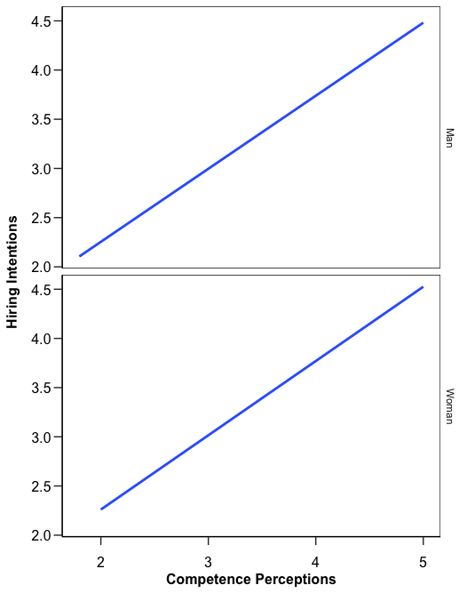

Figure 1b. Two separate line segments plotted in the same line plot with a legend.
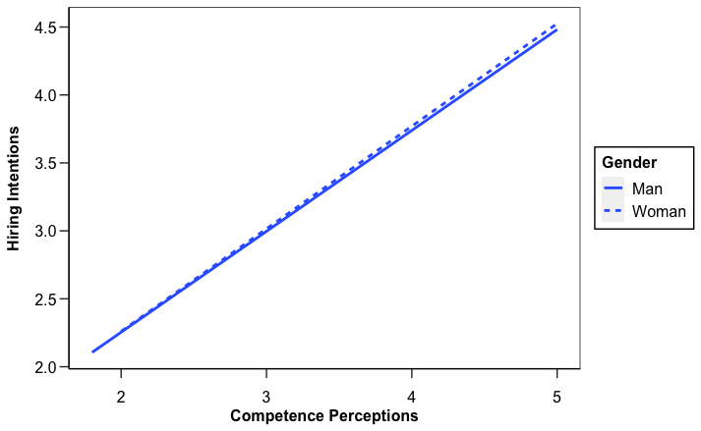

Bar Graphs
Alternatively, one can choose to visualize data points that represent certain values or statistics using a bar chart. Bar charts are possibly the most popular kind of chart used to represent data, depicting the counts or quantities in long rectangular bars. These bars are arranged according to categories on the x-axis, which are compared against each other on either their frequencies or ranks. Bar chart can be oriented in many ways to depict various ideas, but the main orientation tends to be where the x-axis categories are on the bottom and the continuous values are on the y-axis. Thus, bar charts are mainly used to represent comparisons between qualitative data on quantitative dependent variables.
.Generally, bar charts are used to visualize differences in values for different categories. As such, they contain certain key features. Firstly, as these charts are used to represent differences in quality, it is generally recommended to begin the y-axis values at zero and increase them by increments relative to the variable statistics. For example, if one were to represent the population size of a certain number of countries, they would plot the countries on the x-axis, and choose to either represent a raw score in millions, or a limited score in tens while denoting that these represent "millions of people" (Figure 2a). Secondly, the bars should not be broken (i.e., shortening the scales to fit values into the graph), as doing so would not only misrepresent the comparisons, but could also mislead the reading audience regarding the differences between categories. For example, if the comparison between the most populous countries and the rest are represented using a broken bar graph, it would appear that the differences are not as great as they actually are (Figure 2b).
Lastly, bar graph should always be labelled appropriately to align the categorical values to their exact y-axis score. As it is important for readers to know which category scored what, labels allow viewers to understand the comparisons between categories such that the ranking between them remains salient. For example, if the aforementioned graph only had China and India labelled, and the rest labelled as "the rest", it would be difficult to parse the differences between specific countries, especially if one's report specifically compares pairs of countries not labelled in the graph. Other aesthetic recommendations such as color, orientation, and bar aesthetic, amongst others, also require consideration, but are secondary to the three main ideals outlined herein. Thus, special consideration should be paid by researchers seeking to represent the differences between qualitative categories to ensure that these differences are salient to the reader.

Figure 2a. Representing the population size of countries using a limited y-axis scale with a clarifying caption.
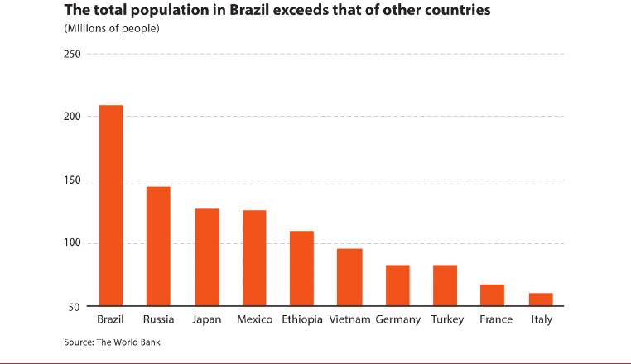
Figure 2b. Representing the population size of countries using a reoriented and non-broken y-axis scale.

Interaction Designs and Plots
Interaction study designs are a core feature of psychological and social studies research, where researchers seek to understand if the relationship between exogenous and exogenous variables are moderated by the levels of another interacting variable. Such designs usually make use of factorial experimental or quasi-experimental studies, which are efficient and powerful tools that allow for two or more variables to be investigated against a dependant -- usually continuous -- outcome (Ali & Peebles, 2013; Bhattacherjee, 2012). Widely used in most scientific branches of study, factorial designs illuminate the interactions between a factored IV with two or more levels against the levels of another moderating variable (MV), which results in matrices of mean values of the DV corresponding to the comparisons between each level of the predictor variables.
Interpreting the results of interaction effects requires conceptual understanding of the simple, main, and conditional effects of each predictor on the outcomes. Using the literature on impression management, for example, one could ask if a job candidates’ strategy to disclose an identity that is invisible to others has an effect on how raters score their perceptions of the candidate’s competence (Lynch & Rodell, 2018; Lyons et al., 2018). If one investigates these effects of disclosure strategies on resultant competence perceptions, one should outline the theoretical explanation for the differences between each level of the strategies on resultant competence perceptions. Furthermore, a researcher could also ask if these results differ if the manipulation of the strategies (in the case of my central study, three vignettes were randomly given to hiring managers outlining an interviewee's strategies) included information about their gender. Thus, the factorial design of such a study would be a 3 x 2 interaction design, where disclosure strategies are compared to the candidate’s gender, further investigating their effects on competence perceptions.
While statistical testing is the primary method that would reveal the actual significance of these effects, the best way to highlight the results of this analysis would be through visualizing these differences. For example, one could plot the primary investigation of strategies against competence perceptions, and either facet out the results by gender, or include the gender comparisons within a single visualization to examine the differences on a single plane. To do so, researchers usually decide to use either a bar graph or a line plot that highlights the direction and magnitude of these differences. Within the management sciences, there are no hard and fast rules for which graph should be used when, but I argue that, as outlined in the previous sections, both graphs should commonly be used for the benefits they afford to researchers who want to highlight both the magnitude and the direction of the interactions without readers having to try to understand the statistical results. Thus, bar and line plots each provide benefits and costs for the analyses of interaction designs when investigating the moderating effect of 2 variables on a given outcome.
Bars versus Lines
When visualizing the differences between groups in an interaction study, a researcher seeks to illuminate the magnitude of the differences between levels to highlight whether these differences may be significant (or not). To do so, most researchers make use of bar graphs that show the extent of the differences between categories against outcomes. In bar graphs, clarity about relationship direction is lost in a bar chart, as it is unclear whether one category is actually significantly different from another, especially when considering three-way interactions between three categories. For example, in Figures 3 and 4, the two bar graphs pictured show the differences between the grouped differences of strategies by gender plotted against competence perceptions and the 3 x 2 interaction plotted against a third variable, i.e., the candidate’s educational affiliation status. However, as one can see in these graphs, the directions of relationships are not clear, and one can be mistaken to not that there does not appear to be an interaction between strategy and gender or between these two and educational status. Contrastingly, the results of such an analysis highlight that there is, in actual fact, a significant effect between candidate gender and disclosure strategy when rated on competence perceptions (F(2, 597) = 56.7, p < .05). Therefore, bar graphs emphasize the magnitude of the differences, but information is lost about the direction of the effects, ambiguating the clarity of the results if there does not appear to be a significant interaction.

Figure 3. Bar chart of two-way interaction of strategy by gender.

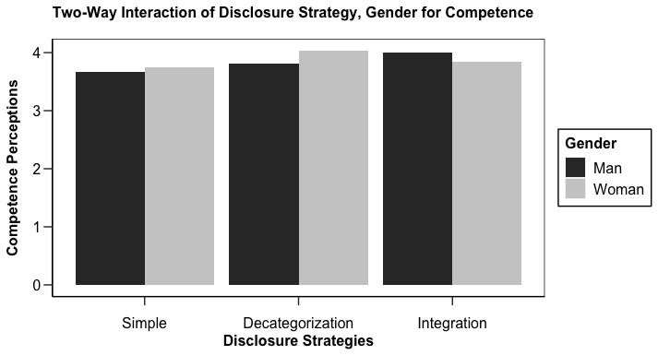

Figure 4. Bar chart of three-way interaction of strategy by gender by education status.
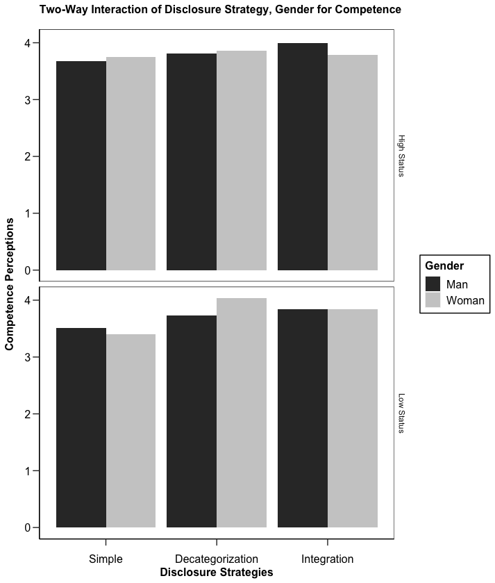

Howbeit, if one decides that the direction of the relationships warrant illumination, a researcher could choose to show the results of this interaction study on a line plot. Although one loses information about the magnitude of the differences between categories, the direction of the relationships between variables are especially highlighted in line charts where the comparison between categories is visualized, especially when considering three-way interactions. For example, two visualizations are plotted in Figure 5 shows the interaction between strategy and gender, and Figure 6 shows a further moderation by the candidate’s educational affiliation status on the effects of the aforementioned 3 x 2 interaction. In bar plots, one cannot include this third moderating variable within the same graph as the added nuances would not only serve to complicate the graph further, but it would also reduce the clarity of the interaction effects between the three predictor variables. However, using line plots, one can clearly see that for female candidates, the difference between simple and decategorization disclosure strategies are moderated by their affiliation to either a high or low status educational institution. The graph clearly shows that when low status females decategorize, they are rated as not only more competent that their high-status female counterparts, but also more competent than both their low and high-status male counterparts. Such a result is a new finding in the field and within the impression management literature, and thus warrants illumination in such a manner. Therefore, line charts highlight the direction of the differences between categories on a given DV better than bar charts, and are thus, a much easier choice to use when visualizing interactions.

Figure 5. Line plot of two-way interaction of strategy by gender.
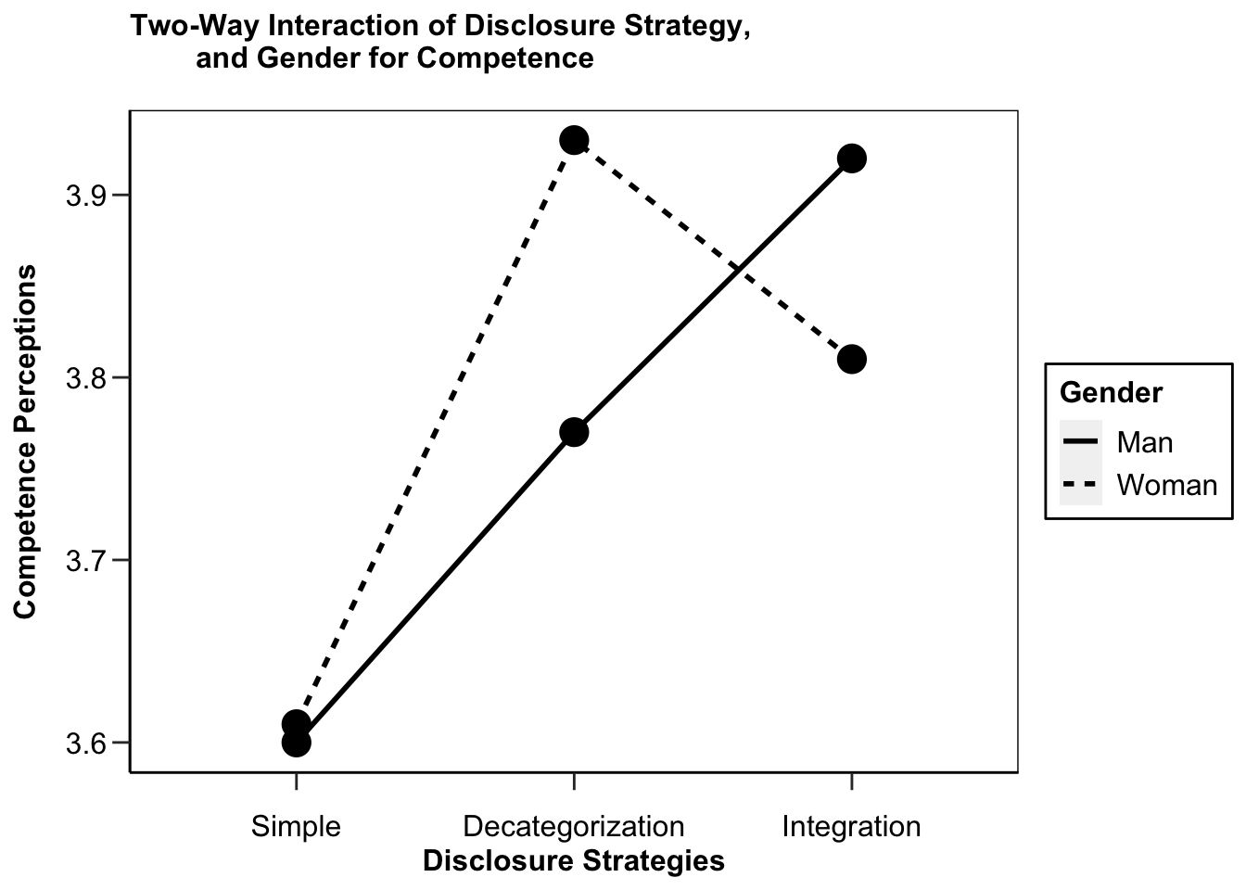
Figure 6. Line plot of three-way interaction of strategy by gender by education status.
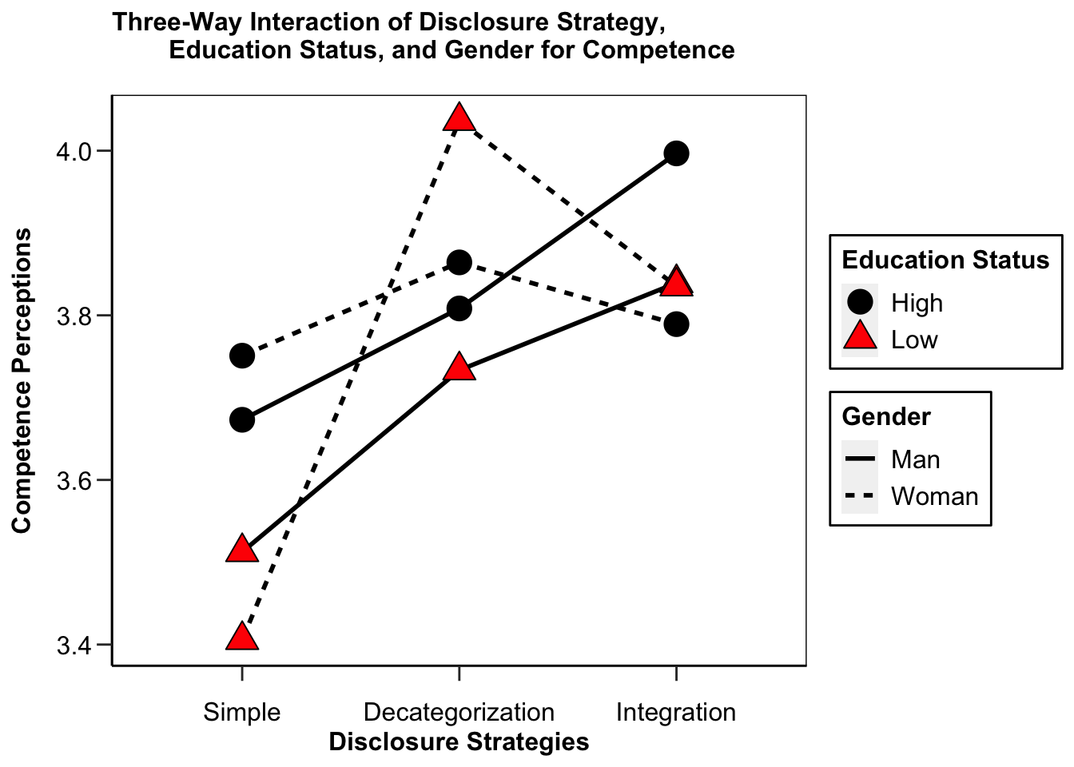

Conclusion
In this paper, an argument for the use of both line and bar charts is proposed when researchers seek to make the magnitude and direction of interactional differences between variables salient. Good visualization principles have been proposed by various researchers (e.g., Ali & Peebles, 2013; Franzblau & Chung, 2012; Gillian & Lewis, 1994) that highlight the ways in which researchers can make use of both bar and line graphs to visualize these results. However, especially within the management literature, scholars have either made use of one or the other or used both for different comparisons when visualizing these results (e.g., Lynch & Rodell, 2018; Lyons et al., 2018). As line and bar graphs allow for the emphasis of both the direction and magnitude of the differences between predictor variables on outcomes, I propose that both of these visual techniques should be used for the benefits they provide both the researcher and the reader in making the results of factorial analyses salient. Thus, this brief outline proposes that scholars within the social and psychological sciences use clear visualizations that emphasize all of the conceptual differences, providing supplemental graphics that clarify their results.

References
Ali, N., & Peebles, D. (2013). The Effect of Gestalt Laws of Perceptual Organization on the Comprehension of Three-Variable Bar and Line Graphs. Human Factors, 55(1), 183-203. https://doi.org/10.1177/0018720812452592.
Annesley, T., M. (2010) Put your best figure forward: line graphs and scattergrams. Clinical Chemistry, 56(8), 1229–1233. https://doi.org/10.1373/clinchem.2010.150060.
Franzblau, L. E., & Chung, K. C. (2012). Graphs, tables, and figures in scientific publications: the good, the bad, and how not to be the latter. The Journal of Hand Surgery, 37(3), 591-596. https://doi.org/10.1016/j.jhsa.2011.12.041.
Gillian & Lewis, 1994; Gillan, D. J., & Lewis, R. (1994). A componential model of human interaction with graphs: 1. Linear regression modeling. Human Factors, 36(3), 419–440. https://doi.org/10.1177/001872089403600303.
Lynch, J. W., & Rodell, J. B. (2018). Blend in or stand out? Interpersonal outcomes of managing concealable stigmas at work. Journal of Applied Psychology, 103(12), 1307–1323. https://doi.org/10.1037/apl0000342.
Lyons, B. J., Martinez, L. R., Ruggs, E. N., Hebl, M. R., Ryan, A. M., O'Brien, K. R., & Roebuck, A. (2018). To say or not to say: Different strategies of acknowledging a visible disability. Journal of Management, 44(5), 1980–2007. https://doi.org/10.1177/0149206316638160.
Rodgers, P., Stapleton, G., & Chapman, G. (2015). Visualizing sets with linear diagrams. ACM Transactions on Computer-Human Interaction, 22(6), 1-39. https://doi.org/10.1145/2810012.
Schwabish, J. (2021). The Practice of Visual Data Communication: What Works. Psychological Science in the Public Interest, 22(3), 97-109. https://doi.org/10.1177/15291006211057899.

