How to purchase your course materials for PSYC 6136
- Go to https://www.bookstore.yorku.ca/buy_textbooks.asp to access the York University Bookstore search.

- Use the filters to locate your course. The screenshot below shows the exact criteria you should select to locate your section. When you have selected the course, click “ADD COURSE TO LIST” then click “GET YOUR BOOKS”.
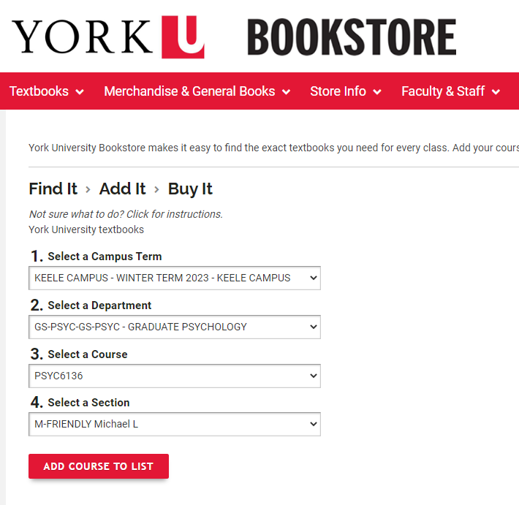

- Select “PURCHASE DIGITAL” and follow the check-out steps to purchase your eBook.
